**SUPPLEMENTARY MATERIALS – ДОПОЛНИТЕЛЬНЫЕ МАТЕРИАЛЫ**

**Heavy metals and metalloids in soils, road dust and their PM10 fractions in Sebastopol: levels, sources and danger of pollution**

**Тяжелые металлы и металлоиды в почвах, дорожной пыли и их фракции PM10 в Севастополе: уровни, источники и опасность загрязнения**

L. A. Bezberdaya, N. S. Kasimov, O. V. Chernitsova, A. N. Tkachenko, M. Y. Lychagin

**Л. А. Безбердая, Н. С. Касимов, О. В. Черницовa, А. Н. Ткаченко, М. Ю. Лычагин**

**Eurasian Soil Science.**

**Почвоведение.**

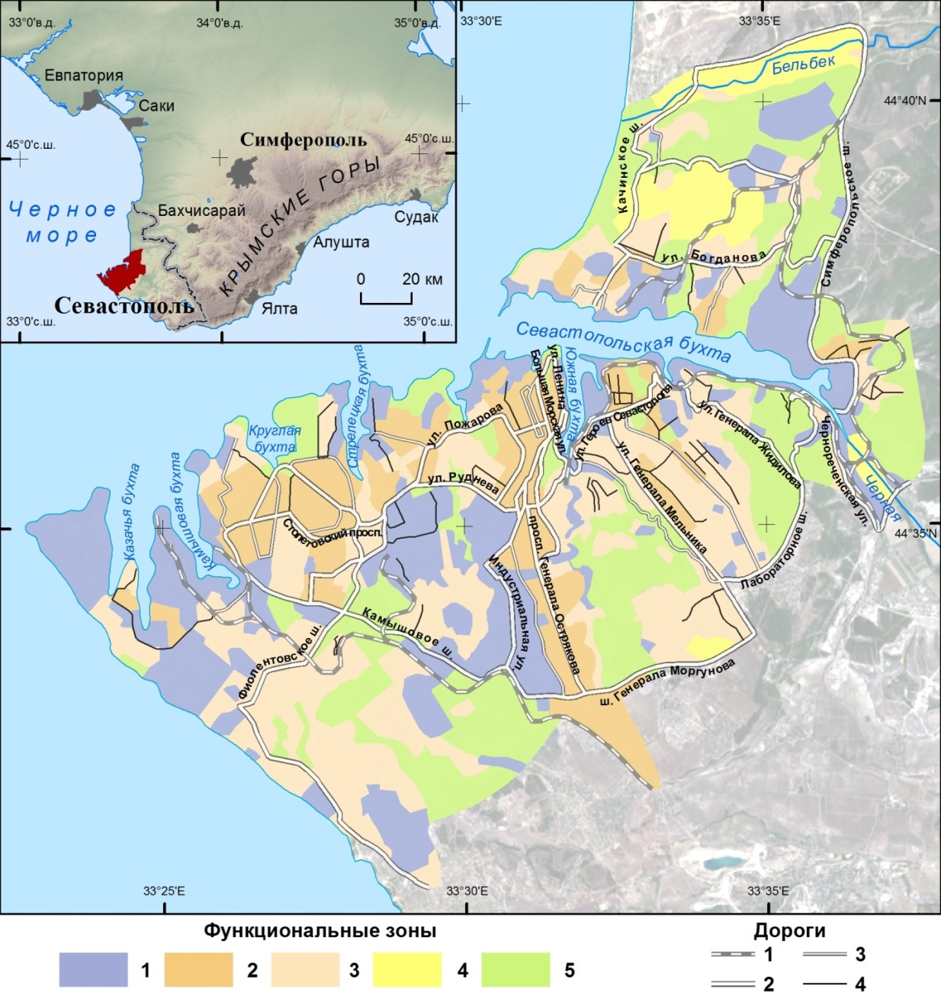

**Fig. S1.** Functional zoning of Sebastopol. Functional zones: 1 – industrial, 2 – residential with multi-storey buildings, 3 – residential with low-rise buildings, 4 - agrogenic, 5 – recreational. Roads: 1 – railway, 2 – large, 3 – medium, 4 – small.

**Рис. S1.** Функциональное зонирование Севастополя. Функциональные зоны: 1 – промышленная, 2 – селитебная с многоэтажной застройкой, 3 – селитебная с малоэтажной застройкой, 4 – агрогенная, 5 – рекреационная. Дороги: 1 – ж/д, 2 – крупные, 3 – средние, 4 – малые.

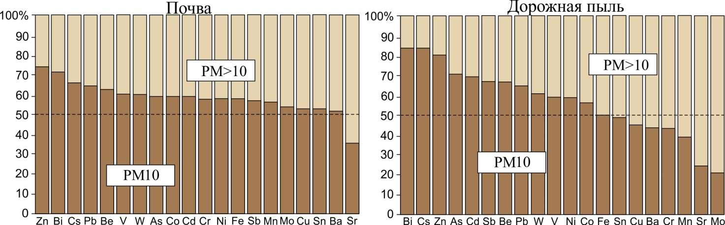

**Fig. S2.** Fractional composition of HMM in soils and road dust of Sebastopol.

**Рис. S2.** Фракционный состав ТММ в почвах и дорожной пыли Севастополя.

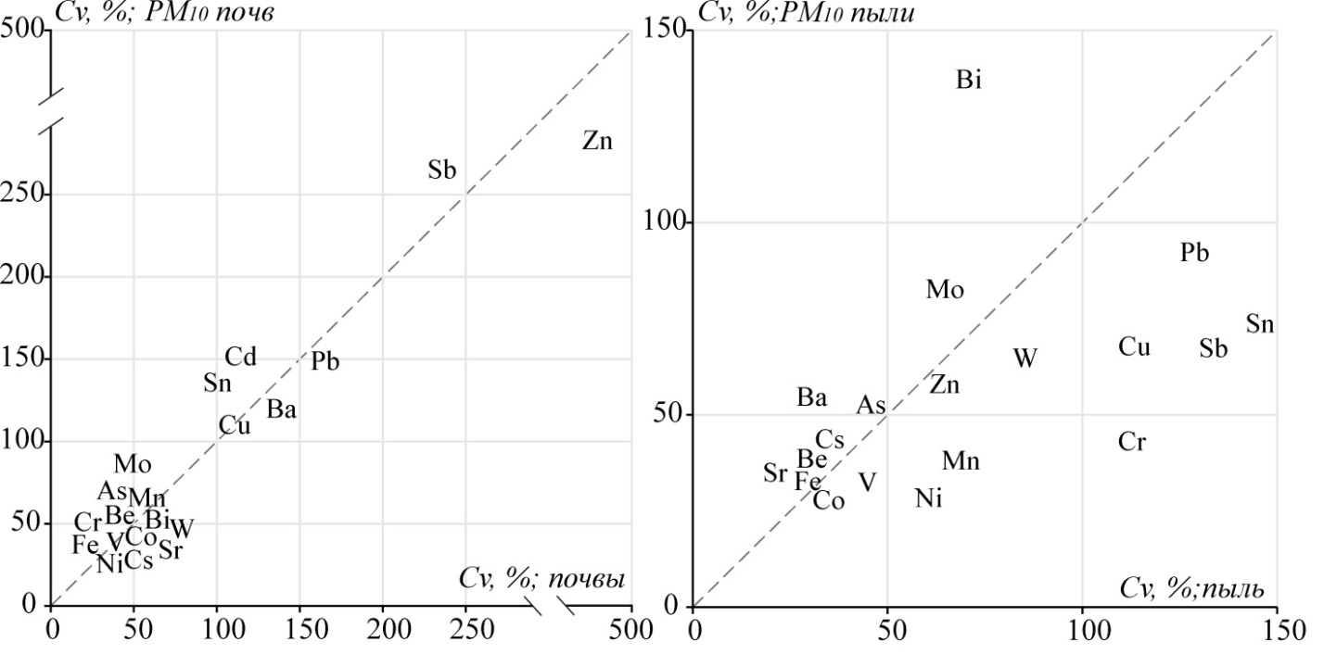

**Fig. S3.** Ratio of coefficients of variation (*Cv*, %) of HMM contents in soils, road dust and their fractions PM10 in Sebastopol.

**Рис. S3.** Соотношение коэффициентов вариации (*Сv*, %) содержаний ТММ в почвах, дорожной пыли и их фракциях РМ10 в Севастополе.

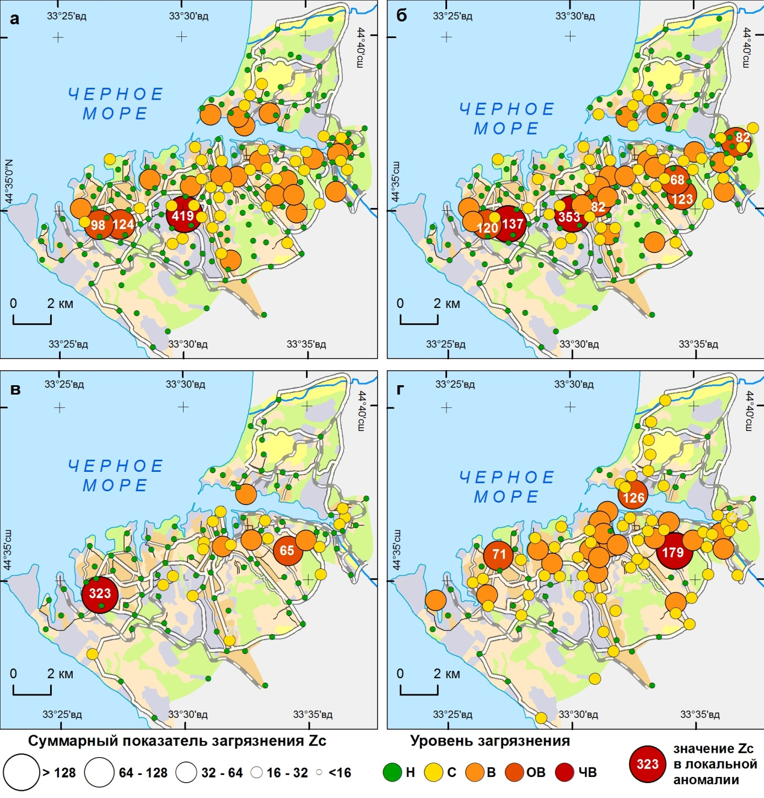

**Fig. S4.** Суммарное загрязнение почв (а), частиц PM10 почв (б), дорожной пыли (в) и частиц PM10 пыли (г) в Севастополе.

**Рис. S4.** Total pollution of soils (a), PM10 soil particles (b), road dust (c) and PM10 dust particles (d) in Sebastopol.

**Table S1.** Values of factor loads for HMM concentrations in soils, road dust and their PM10 particles in Sebastopol.

**Таблица S1.** Значения факторных нагрузок для концентраций ТММ в почвах, дорожной пыли и их частицах РМ10 в Севастополе.

|  |  |  |  |  |  |  |  |  |  |  |  |  |  |  |  |  |
| --- | --- | --- | --- | --- | --- | --- | --- | --- | --- | --- | --- | --- | --- | --- | --- | --- |
| Элемент | Почвы | | | | РМ10 почв | | | | Дорожная пыль | | | | РМ10 пыли | | | |
| PC1 | PC2 | PC3 | PC4 | PC1 | PC2 | PC3 | PC4 | PC1 | PC2 | PC3 | PC4 | PC1 | PC2 | PC3 | PC4 |
| Be | **0.943** |  |  |  | **0.967** |  |  |  | **0.746** |  |  |  | **0.929** |  |  |  |
| V | **0.969** |  |  |  | **0.975** |  |  |  | **0.734** |  |  |  | **0.940** |  |  |  |
| Cr | *0.515* |  |  | *0.621* | *0.555* |  | 0.473 |  |  |  |  | **0.829** | **0.787** |  | 0.323 |  |
| Mn | *0.578* | 0.344 |  |  | *0.587* | *0.663* |  |  |  |  | 0.496 | *0.559* | **0.799** | 0.339 |  |  |
| Fe | **0.943** |  |  |  | **0.968** |  |  |  | *0.668* |  | 0.456 | 0.433 | **0.918** |  | 0.304 |  |
| Co | **0.811** | *0.526* |  |  | **0.870** | 0.413 |  |  | **0.863** |  |  | 0.317 | **0.931** |  |  |  |
| Ni | **0.931** |  |  |  | **0.910** |  |  |  | 0.442 | 0.317 |  | **0.701** | **0.839** |  |  |  |
| Cu |  |  | **0.713** | 0.305 |  |  | *0.506* | *0.681* |  |  | 0.393 |  |  | *0.525* | *0.666* |  |
| Zn |  | **0.977** |  |  |  | **0.961** |  |  |  |  | **0.737** |  |  | *0.601* | *0.523* | 0.306 |
| As | **0.839** |  |  |  | **0.767** |  |  | 0.414 | *0.674* |  |  |  | **0.800** |  |  |  |
| Sr |  |  |  |  |  | 0.367 |  | 0.499 |  |  |  |  |  | 0.345 |  | **0.716** |
| Mo |  |  | *0.648* |  |  |  |  | **0.811** |  |  | *0.641* |  | 0.312 | 0.359 | **0.731** |  |
| Cd |  | *0.544* | *0.524* | 0.413 |  | *0.615* | *0.619* |  |  | **0.883** |  |  |  | **0.934** |  |  |
| Sn |  | 0.370 | **0.780** |  |  | 0.431 | **0.724** | 0.337 |  | 0.383 |  |  |  | *0.625* | *0.562* |  |
| Sb |  | **0.936** |  |  |  | **0.933** |  |  |  | **0.863** |  |  |  | 0.444 | **0.717** |  |
| Cs | **0.946** |  |  |  | **0.949** |  |  |  | **0.780** |  |  |  | **0.963** |  |  |  |
| Ba |  | **0.930** |  |  |  | *0.668* | *0.559* |  |  |  | *0.665* |  | 0.394 | **0.756** |  |  |
| W |  |  |  | **0.851** | *0.527* |  | 0.356 |  |  |  | *0.618* | 0.450 |  |  | **0.797** |  |
| Pb |  |  | **0.729** |  |  |  | **0.803** |  |  | **0.868** |  |  |  | **0.906** |  |  |
| Bi | 0.473 |  | 0.471 |  | 0.383 |  | 0.457 |  | 0.374 | 0.317 |  |  |  |  |  | **0.876** |
| Eigenvalue | 7.4 | 5.1 | 1.9 | 1.1 | 7.7 | 5.3 | 1.6 | 1.1 | 5.7 | 3.0 | 1.8 | 1.6 | 10.5 | 3.6 | 1.4 | 1.1 |
| Variance, % | 37 | 25 | 9.4 | 5.5 | 39 | 26 | 8.1 | 5.5 | 28.4 | 15.2 | 9.2 | 8.1 | 52.3 | 18.2 | 6.9 | 5.4 |
| Cumul. var., % | 37 | 62 | 72 | 77 | 39 | 65 | 73 | 79 | 28.4 | 43.6 | 52.8 | 60.9 | 52.3 | 70.5 | 77.4 | 82.8 |

*Примечание*. **Полужирным** выделены значения факторных нагрузок > 0.7 (сильная связь), *курсивом* – > 0.5 (средняя связь), не показаны нагрузки < 0.3

**Table S2.** Correlation coefficients (*r*) for HMM in soils, road dust and their fractions PM10.

**Таблица S2.** Коэффициенты корреляции (*r*) для ТММ в почвах, дорожной пыли и их фракциях РМ10.

|  |  |  |  |  |  |  |  |  |  |  |  |  |  |  |  |  |  |  |  |  |
| --- | --- | --- | --- | --- | --- | --- | --- | --- | --- | --- | --- | --- | --- | --- | --- | --- | --- | --- | --- | --- |
| ***Почвы*** | | | | | | | | | | | | | | | | | | | | |
| ТММ | Be | V | Cr | Mn | Fe | Co | Ni | Cu | Zn | As | Sr | Mo | Cd | Sn | Sb | Cs | Ba | W | Pb | Bi |
| Be | 0.72 | 0.93 | 0.44 | 0.43 | 0.88 | 0.73 | 0.86 | -0.17 | -0.09 | 0.77 | -0.65 | -0.05 | -0.25 | -0.16 | -0.13 | 0.92 | 0.02 | 0.15 | -0.18 | 0.35 |
| V | 0.95 | 0.73 | 0.49 | 0.52 | 0.94 | 0.77 | 0.89 | -0.15 | -0.07 | 0.77 | -0.66 | -0.06 | -0.23 | -0.15 | -0.12 | 0.95 | 0.05 | 0.17 | -0.20 | 0.36 |
| Cr | 0.45 | 0.50 | 0.69 | 0.45 | 0.59 | 0.49 | 0.60 | 0.15 | 0.15 | 0.41 | -0.27 | 0.21 | 0.34 | 0.19 | 0.17 | 0.45 | 0.27 | 0.54 | 0.16 | 0.22 |
| Mn | 0.49 | 0.54 | 0.40 | 0.79 | 0.57 | 0.65 | 0.56 | 0.11 | 0.29 | 0.53 | -0.29 | 0.22 | 0.11 | 0.10 | 0.26 | 0.43 | 0.35 | 0.25 | -0.03 | 0.23 |
| Fe | 0.94 | 0.96 | 0.51 | 0.54 | 0.73 | 0.77 | 0.92 | -0.01 | -0.03 | 0.78 | -0.56 | 0.10 | -0.08 | -0.01 | -0.06 | 0.88 | 0.12 | 0.33 | -0.10 | 0.37 |
| Co | 0.81 | 0.84 | 0.52 | 0.81 | 0.82 | 0.77 | 0.80 | 0.01 | 0.49 | 0.66 | -0.43 | 0.17 | 0.18 | 0.20 | 0.42 | 0.71 | 0.62 | 0.23 | 0.05 | 0.37 |
| Ni | 0.85 | 0.87 | 0.58 | 0.60 | 0.87 | 0.86 | 0.67 | 0.03 | 0.05 | 0.78 | -0.59 | 0.13 | 0.02 | 0.06 | 0.01 | 0.87 | 0.20 | 0.32 | -0.02 | 0.38 |
| Cu | -0.10 | -0.09 | 0.12 | 0.14 | -0.07 | 0.09 | 0.13 | 0.88 | 0.12 | 0.00 | 0.22 | 0.51 | 0.46 | 0.54 | 0.19 | -0.23 | 0.20 | 0.32 | 0.40 | 0.14 |
| Zn | -0.11 | -0.06 | 0.23 | 0.57 | -0.07 | 0.37 | 0.11 | 0.21 | 0.98 | 0.00 | 0.23 | 0.28 | 0.55 | 0.37 | 0.94 | -0.10 | 0.91 | 0.09 | 0.23 | 0.06 |
| As | 0.73 | 0.71 | 0.34 | 0.51 | 0.70 | 0.70 | 0.73 | 0.20 | 0.03 | 0.75 | -0.45 | 0.22 | -0.11 | 0.04 | 0.01 | 0.73 | 0.10 | 0.23 | -0.04 | 0.36 |
| Sr | -0.35 | -0.30 | 0.03 | 0.09 | -0.31 | -0.08 | -0.13 | 0.34 | 0.35 | -0.11 | 0.67 | 0.28 | 0.27 | 0.22 | 0.27 | -0.69 | 0.18 | -0.09 | 0.24 | -0.16 |
| Mo | 0.18 | 0.15 | 0.15 | 0.34 | 0.15 | 0.37 | 0.35 | 0.56 | 0.29 | 0.46 | 0.31 | 0.73 | 0.46 | 0.52 | 0.35 | -0.17 | 0.33 | 0.36 | 0.37 | 0.18 |
| Cd | -0.13 | -0.11 | 0.42 | 0.35 | -0.09 | 0.18 | 0.13 | 0.41 | 0.66 | -0.02 | 0.29 | 0.33 | 0.94 | 0.66 | 0.58 | -0.27 | 0.62 | 0.44 | 0.55 | 0.14 |
| Sn | -0.10 | -0.07 | 0.24 | 0.30 | -0.04 | 0.23 | 0.18 | 0.65 | 0.54 | 0.17 | 0.32 | 0.45 | 0.64 | 0.86 | 0.42 | -0.20 | 0.55 | 0.22 | 0.66 | 0.20 |
| Sb | -0.10 | -0.06 | 0.26 | 0.58 | -0.07 | 0.37 | 0.12 | 0.29 | 0.97 | 0.07 | 0.39 | 0.37 | 0.67 | 0.57 | 0.94 | -0.17 | 0.85 | 0.13 | 0.34 | 0.06 |
| Cs | 0.95 | 0.96 | 0.43 | 0.44 | 0.92 | 0.77 | 0.83 | -0.16 | -0.14 | 0.67 | -0.37 | 0.06 | -0.18 | -0.15 | -0.15 | 0.76 | 0.01 | 0.11 | -0.23 | 0.35 |
| Ba | 0.03 | 0.08 | 0.31 | 0.49 | 0.08 | 0.42 | 0.30 | 0.36 | 0.71 | 0.13 | 0.27 | 0.32 | 0.65 | 0.81 | 0.69 | 0.00 | 0.89 | 0.16 | 0.36 | 0.18 |
| W | 0.44 | 0.45 | 0.62 | 0.43 | 0.50 | 0.53 | 0.53 | 0.31 | 0.26 | 0.43 | 0.04 | 0.48 | 0.47 | 0.28 | 0.31 | 0.38 | 0.27 | 0.76 | 0.13 | 0.10 |
| Pb | -0.12 | -0.11 | 0.20 | 0.11 | -0.09 | 0.04 | 0.09 | 0.47 | 0.27 | 0.09 | 0.24 | 0.30 | 0.52 | 0.74 | 0.37 | -0.17 | 0.58 | 0.18 | 0.89 | 0.13 |
| Bi | 0.34 | 0.34 | 0.35 | 0.28 | 0.33 | 0.37 | 0.44 | 0.29 | 0.12 | 0.37 | 0.13 | 0.35 | 0.23 | 0.34 | 0.16 | 0.30 | 0.34 | 0.29 | 0.30 | 0.74 |
| ***Дорожная пыль*** | | | | | | | | | | | | | | | | | | | | |
| ТММ | Be | V | Cr | Mn | Fe | Co | Ni | Cu | Zn | As | Sr | Mo | Cd | Sn | Sb | Cs | Ba | W | Pb | Bi |
| Be | 0.76 | 0.39 | 0.12 | 0.30 | 0.51 | 0.64 | 0.22 | 0.13 | 0.23 | 0.49 | -0.23 | 0.27 | -0.14 | 0.04 | -0.14 | 0.69 | 0.48 | 0.14 | -0.04 | 0.12 |
| V | 0.86 | 0.70 | 0.10 | 0.32 | 0.72 | 0.79 | 0.40 | 0.27 | 0.13 | 0.27 | -0.31 | 0.04 | 0.02 | 0.03 | 0.06 | 0.32 | 0.14 | 0.08 | 0.12 | 0.22 |
| Cr | 0.76 | 0.79 | 0.42 | 0.52 | 0.50 | 0.37 | 0.81 | 0.06 | 0.22 | 0.14 | -0.12 | 0.25 | 0.29 | 0.06 | 0.32 | -0.01 | 0.18 | 0.33 | 0.26 | -0.13 |
| Mn | 0.74 | 0.77 | 0.76 | 0.58 | 0.69 | 0.49 | 0.47 | 0.14 | 0.53 | 0.29 | -0.04 | 0.25 | 0.08 | 0.13 | 0.23 | 0.12 | 0.34 | 0.51 | 0.25 | -0.01 |
| Fe | 0.88 | 0.97 | 0.84 | 0.81 | 0.69 | 0.81 | 0.60 | 0.34 | 0.50 | 0.48 | -0.14 | 0.43 | 0.09 | 0.14 | 0.24 | 0.31 | 0.45 | 0.39 | 0.28 | 0.17 |
| Co | 0.88 | 0.93 | 0.80 | 0.81 | 0.94 | 0.71 | 0.60 | 0.22 | 0.31 | 0.52 | -0.26 | 0.20 | 0.04 | 0.02 | 0.06 | 0.55 | 0.32 | 0.20 | 0.13 | 0.24 |
| Ni | 0.81 | 0.86 | 0.85 | 0.71 | 0.85 | 0.87 | 0.47 | 0.06 | 0.23 | 0.31 | -0.19 | 0.21 | 0.31 | 0.04 | 0.27 | 0.21 | 0.16 | 0.19 | 0.34 | 0.09 |
| Cu | 0.27 | 0.41 | 0.49 | 0.43 | 0.47 | 0.45 | 0.49 | 0.62 | 0.24 | 0.25 | -0.12 | 0.29 | 0.00 | 0.09 | 0.10 | -0.05 | 0.18 | 0.15 | 0.07 | 0.08 |
| Zn | 0.32 | 0.40 | 0.53 | 0.47 | 0.47 | 0.42 | 0.54 | 0.75 | 0.80 | 0.26 | 0.08 | 0.38 | 0.06 | 0.21 | 0.19 | 0.04 | 0.51 | 0.33 | 0.30 | 0.19 |
| As | 0.80 | 0.72 | 0.67 | 0.71 | 0.72 | 0.73 | 0.73 | 0.24 | 0.37 | 0.72 | -0.09 | 0.21 | -0.04 | 0.08 | -0.01 | 0.61 | 0.20 | 0.02 | 0.05 | 0.11 |
| Sr | 0.33 | 0.27 | 0.43 | 0.33 | 0.34 | 0.35 | 0.52 | 0.37 | 0.52 | 0.42 | 0.74 | -0.03 | 0.12 | -0.01 | 0.17 | -0.20 | 0.08 | 0.11 | 0.13 | 0.01 |
| Mo | 0.37 | 0.48 | 0.62 | 0.42 | 0.56 | 0.45 | 0.58 | 0.72 | 0.69 | 0.30 | 0.46 | 0.30 | 0.05 | 0.12 | 0.19 | 0.01 | 0.34 | 0.39 | 0.13 | 0.05 |
| Cd | 0.11 | 0.15 | 0.36 | 0.40 | 0.21 | 0.18 | 0.37 | 0.58 | 0.65 | 0.25 | 0.40 | 0.48 | 0.22 | 0.13 | 0.82 | -0.10 | 0.00 | -0.01 | 0.71 | 0.08 |
| Sn | 0.10 | 0.17 | 0.41 | 0.26 | 0.24 | 0.16 | 0.34 | 0.68 | 0.66 | 0.15 | 0.30 | 0.69 | 0.64 | 0.60 | 0.26 | -0.05 | 0.08 | 0.13 | 0.31 | 0.19 |
| Sb | 0.34 | 0.42 | 0.55 | 0.42 | 0.50 | 0.41 | 0.51 | 0.74 | 0.76 | 0.35 | 0.44 | 0.80 | 0.50 | 0.65 | 0.40 | -0.16 | 0.07 | 0.24 | 0.70 | 0.08 |
| Cs | 0.92 | 0.91 | 0.75 | 0.69 | 0.89 | 0.87 | 0.84 | 0.21 | 0.24 | 0.77 | 0.26 | 0.35 | 0.08 | 0.05 | 0.28 | 0.79 | 0.16 | -0.09 | -0.06 | 0.15 |
| Ba | 0.45 | 0.47 | 0.60 | 0.63 | 0.55 | 0.51 | 0.59 | 0.65 | 0.70 | 0.45 | 0.52 | 0.64 | 0.84 | 0.59 | 0.58 | 0.39 | 0.90 | 0.24 | 0.19 | 0.18 |
| W | 0.27 | 0.36 | 0.40 | 0.30 | 0.42 | 0.41 | 0.29 | 0.49 | 0.40 | 0.11 | 0.20 | 0.50 | 0.18 | 0.33 | 0.54 | 0.16 | 0.31 | 0.51 | 0.09 | -0.11 |
| Pb | 0.12 | 0.11 | 0.31 | 0.34 | 0.16 | 0.17 | 0.31 | 0.56 | 0.60 | 0.24 | 0.41 | 0.37 | 0.81 | 0.57 | 0.53 | 0.05 | 0.69 | 0.15 | 0.86 | 0.20 |
| Bi | 0.39 | 0.27 | 0.32 | 0.34 | 0.35 | 0.30 | 0.33 | 0.26 | 0.40 | 0.41 | 0.52 | 0.29 | 0.17 | 0.23 | 0.21 | 0.22 | 0.41 | 0.11 | 0.11 | 0.38 |

*Примечание.* Красным выделены значения *r*, значимые при *p* < 0.001. Главная диагональ – величина *r* между содержанием ТММ в почвах или дорожной пыли и в их частицах РМ10, выше главной диагонали – *r* между концентрациями ТММ в почвах или пыли, ниже главной диагонали – *r* между концентрациями ТММ в частицах РМ10 почв или пыли