**Supplementary data**

Table S1. Crystal data, data collection, and refinement parameters for **I**

Compound

[Sc(Ur)2(H2O)(NO3)(μ-OH)2(NO3)(H2O)(Ur)2Sc](NO3)2

*M*

648.26

Crystal system

monoclinic

Space group

*P*21/*n*

*a*, Å

7.8070(3)

*b*, Å

7.7740(3)

*c*, Å

19.7300(7)

β, °

95.000(2)

*V*, Å

1192.89(8)

*T*, K

296.15

*Z*

2

ρ, g/cm3

1.805

Independent reflections

2735

Restrained GooF

1034

*R1*/w*R2* [I≥2σ(I)]

0.0357/0.0838

Table S2. Bond distances and angles for **I**

Table S3. Hydrogen bonds in **I**

D–H, Å

H…A, Å

D…A, Å

D–H…A, °

D–H…A

0.71(2)

2.61(2)

3.174(2)

138(2)

O1 – H1…O6

0.77(3)

2.01(3)

2.769(2)

168(3)

O1W–H1A…05

0.78(3)

2.01(3)

2.775(3)

169(2)

O1W – H1B…O6

Bond distances, Å

Bond angles, °

Sc1–O1 2.063(2) Sc1–O1a 2.086(1) Sc1–O2 2.298(1) Sc1–O3 2.337(2) Sc1–O8 2.092(1) Sc1–O9 2.068(1) Sc1–O1W 2.189(2) Sc1a–O1 2.063(1) Sc1a–O1a 2.086(2) Sc1a–O2a 2.298(1) Sc1a–O3a 2.337(2) Sc1a–O8a 2.092(1) Sc1a–O9a 2.068(1) Sc1–O1Wa 2.189(2)

Sc1–O1–Sc1a 107.8(1) Sc1–O1a–Sc1a 107.8(1) Sc1–O8–C1 141.4(1) Sc1–O9–C2 141.1(1) Sc1–O2–N1 95.6(1) Sc1–O3–N1 94.0(1) Sc1a–O8a–C1a 141.4(1) Sc1a–O9a–C2a 141.1(1) Sc1a–O2a–N1a 95.6(1) Sc1a–O3a–N1a 94.0(1)

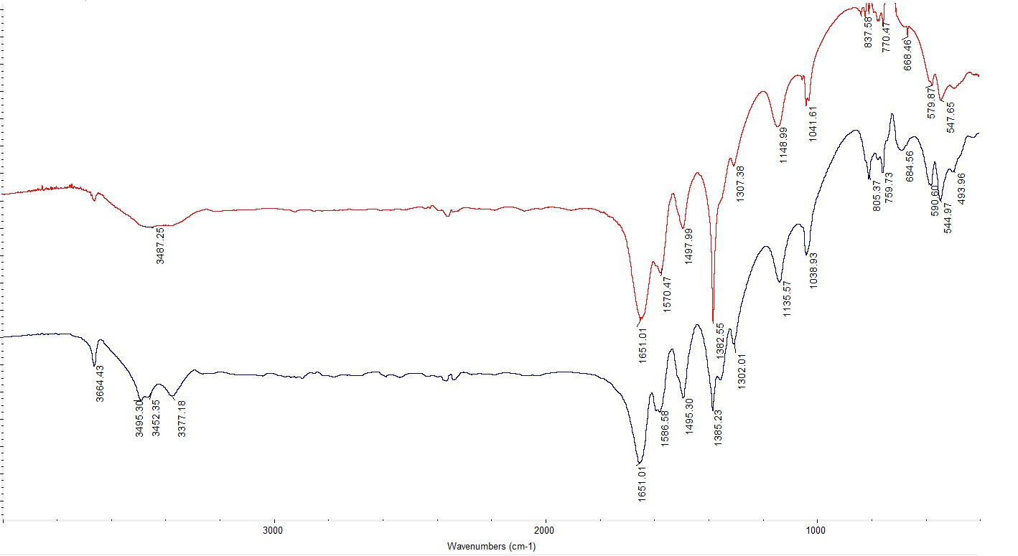

Fig. S1. IR spectra of the complex **II** (upper red) and complex **I** (lower blue).

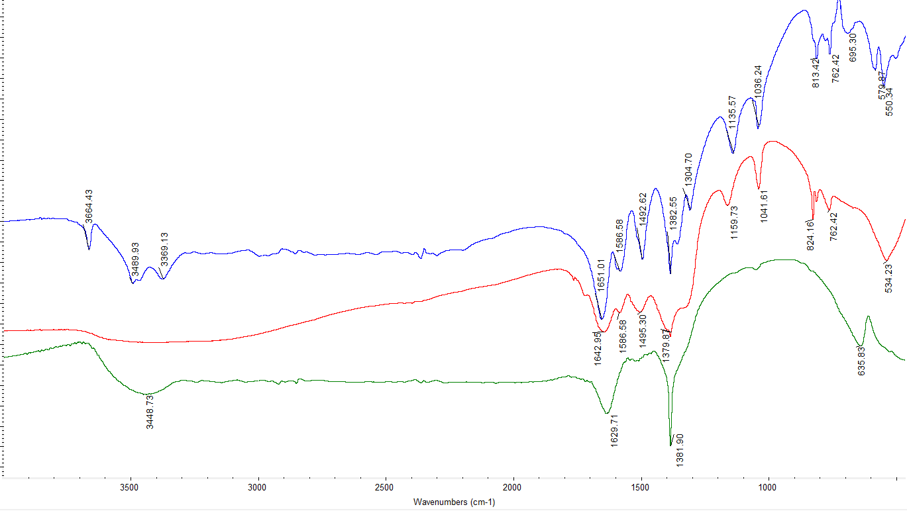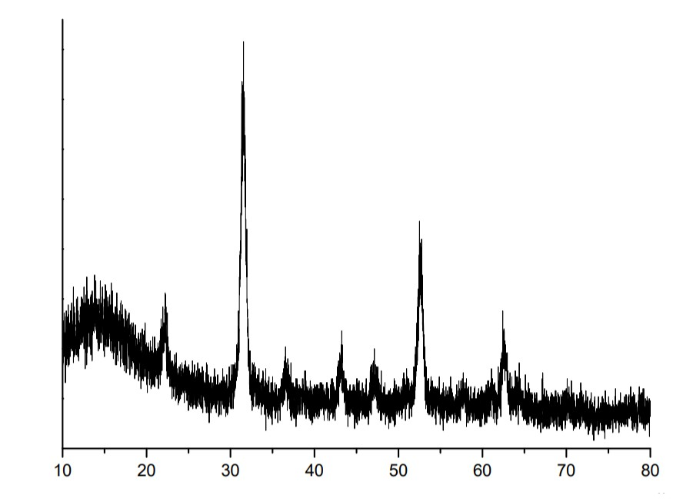

Fig. S2. IR spectra of [Sc(Ur)4(H2O)(NO3)2]NO3 (upper blue) and products of its thermal

decomposition at 230°C (middle red) and 300°C (lower green).

Fig. S3. Powder X-ray diffraction pattern of Sc2O3 prepared by thermal decomposition of **II**.

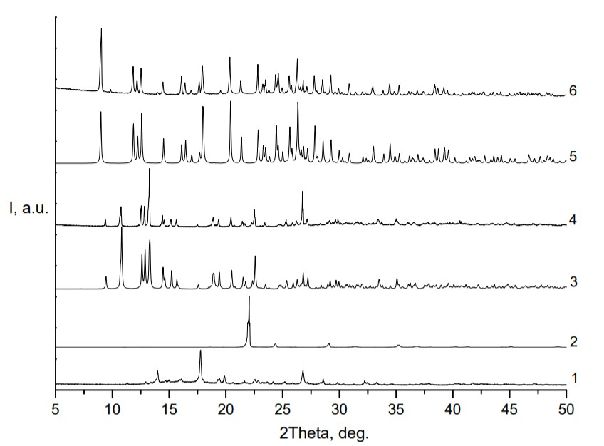

Fig. S4. Powder X-ray diffraction patterns: 1) Ur; 2) Sc(NO3)3∙2H2O; 3) calculated powder X-ray

diffraction pattern for complex **II**; 4) experimental powder X-ray diffraction pattern for complex **II**;

5) calculated powder X-ray diffraction pattern for complex **I**; 6) experimental powder X-ray diffraction pattern for complex **I**.

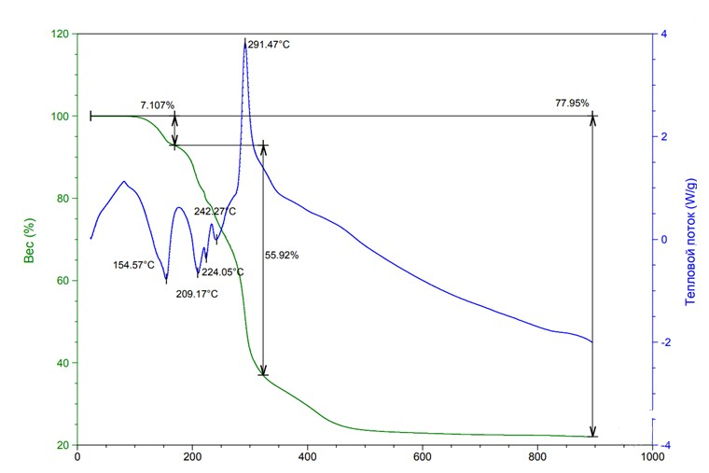

Fig. S5. Thermal curves for **II**.