Supplementary materials - Дополнительные материалы
Синтез порошков аморфного фосфата кальция для изготовления биокерамики и композитов методами 3d-печати
Д. М. Зуев, Д. А. Голубчиков, П. В. Евдокимов, В.И. Путляев
Synthesis of amorphous calcium phosphate powders for the manufacture of bioceramics and composites using 3D printing methods
D. M. Zuev, D. A. Golubchikov, P. V. Evdokimov, V. I. Putlayev
Russian Journal of Inorganic Chemistry
Журнал неорганической химии
Effect of inhibitors on ACP crystallization
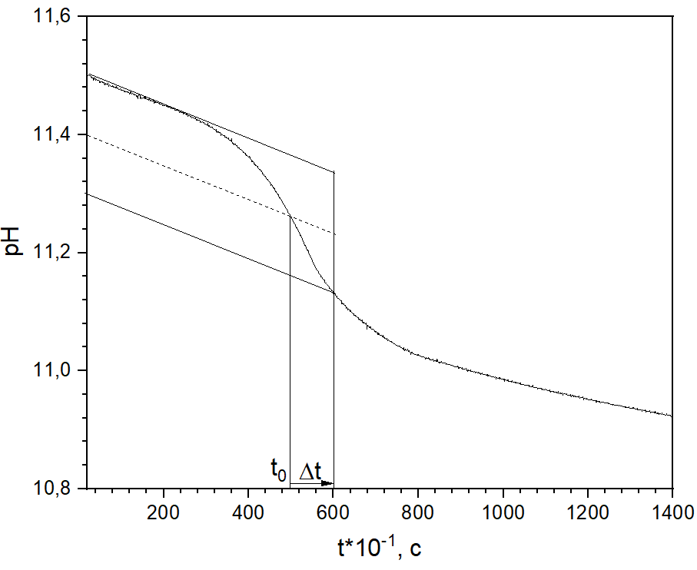
Fig. S1. Determination of t₀ and Δt.
Рис. S1. Определение t₀ и Δt
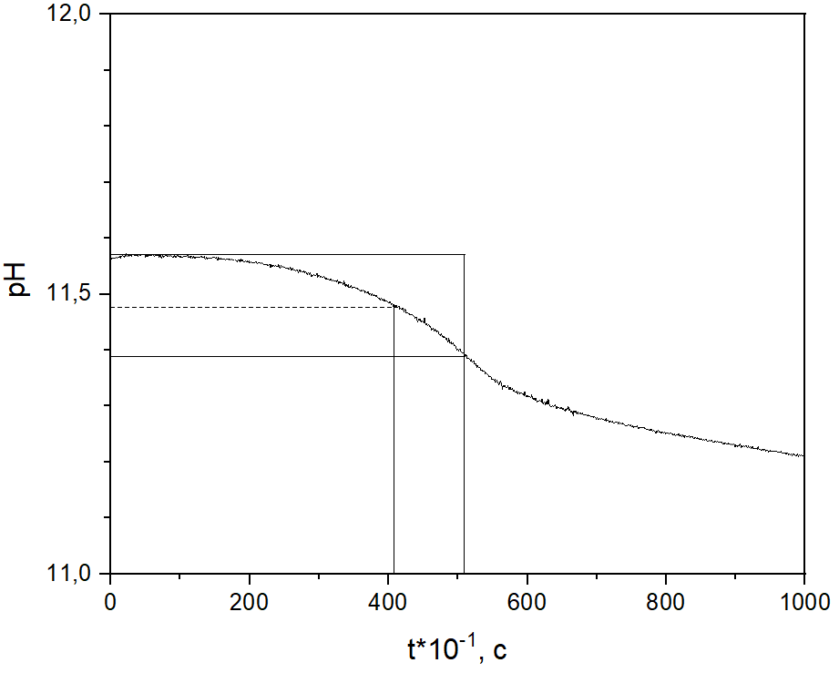  a | 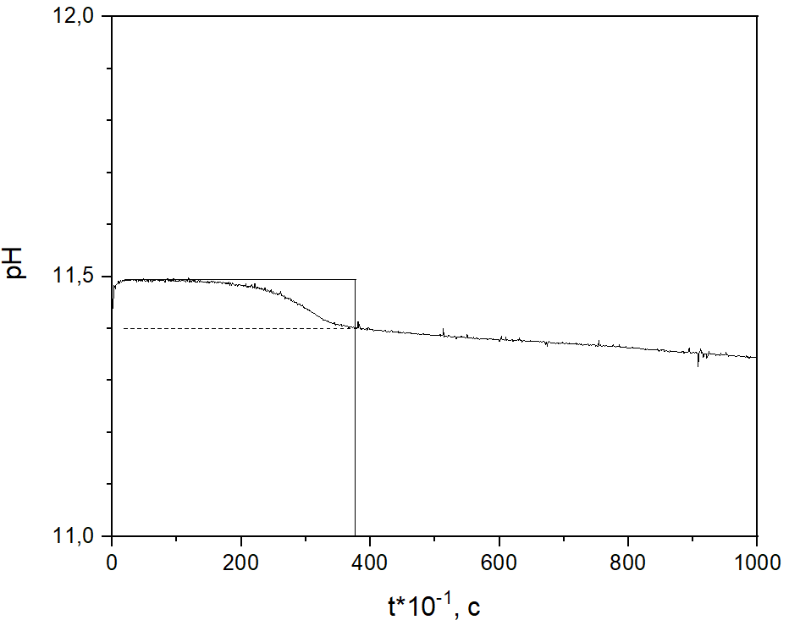  b
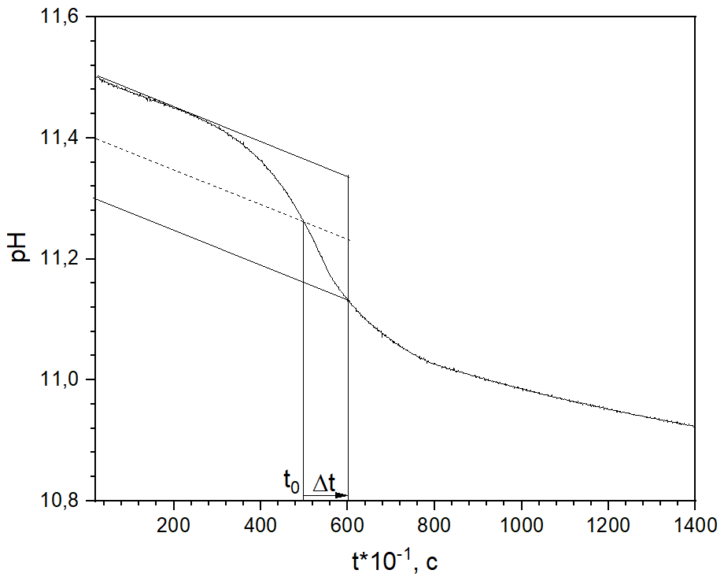  c | 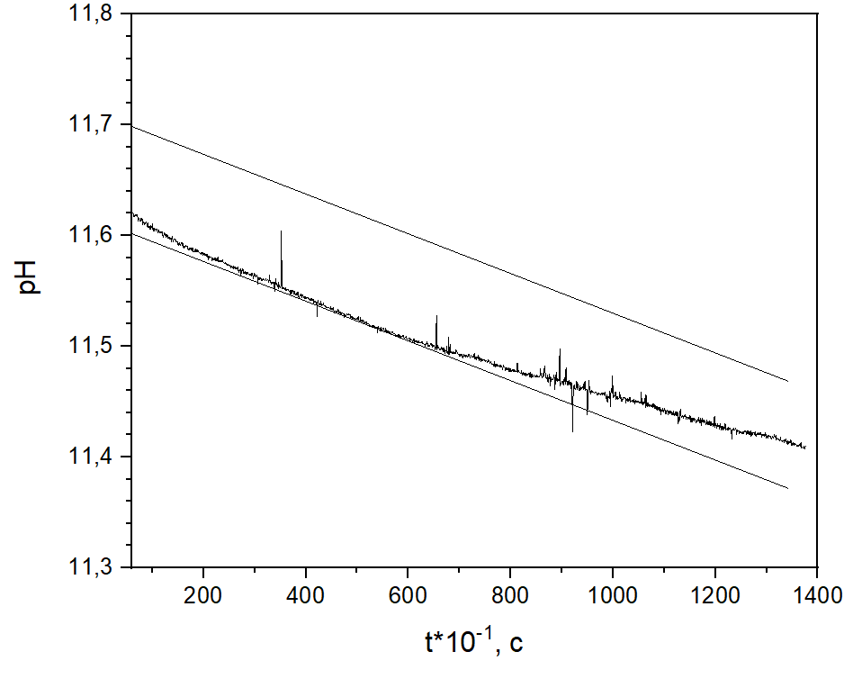  d
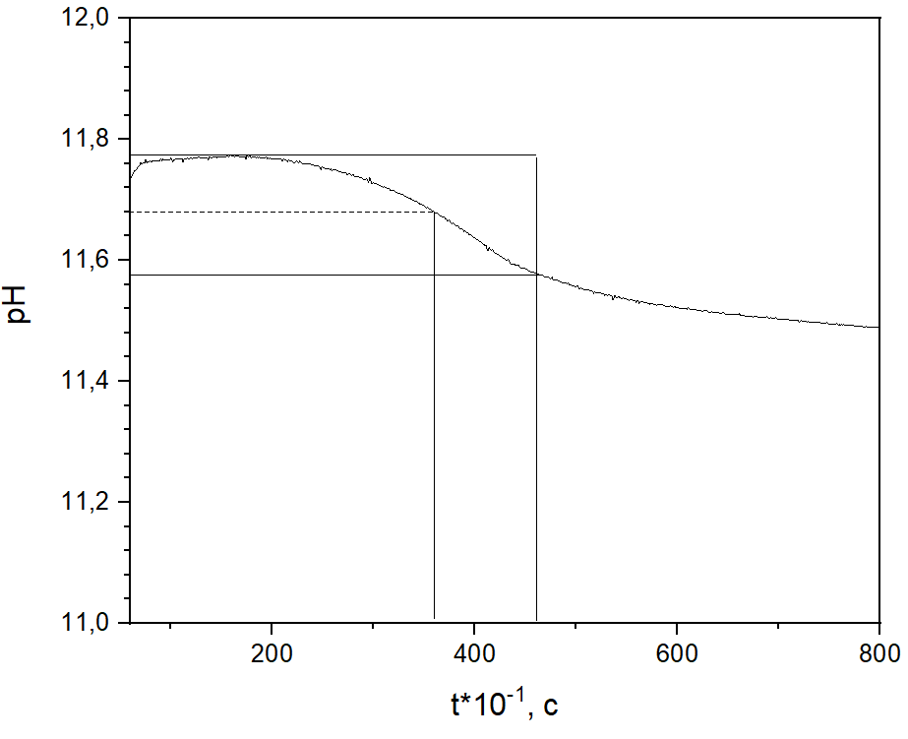  e | 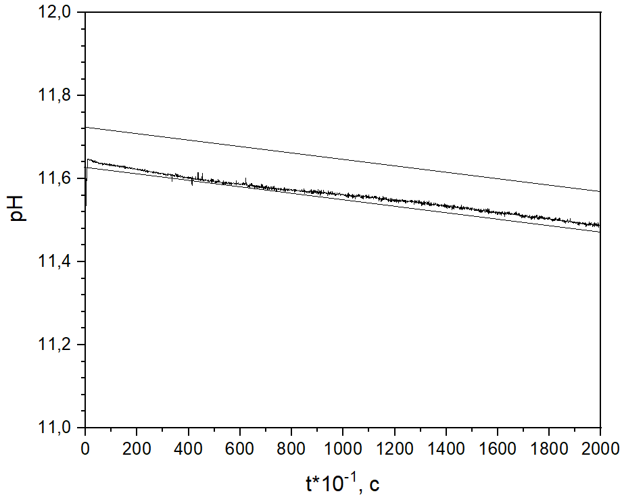  f
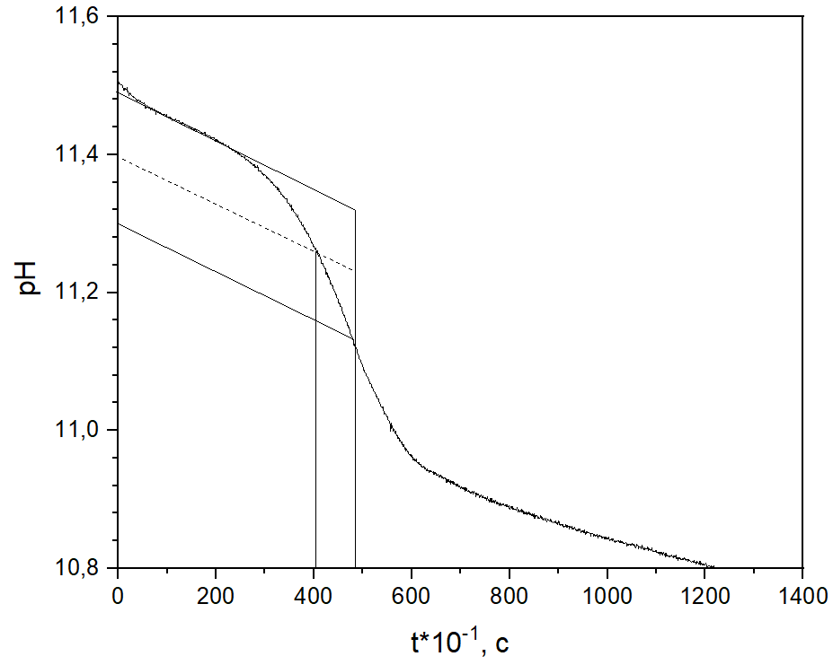  g | 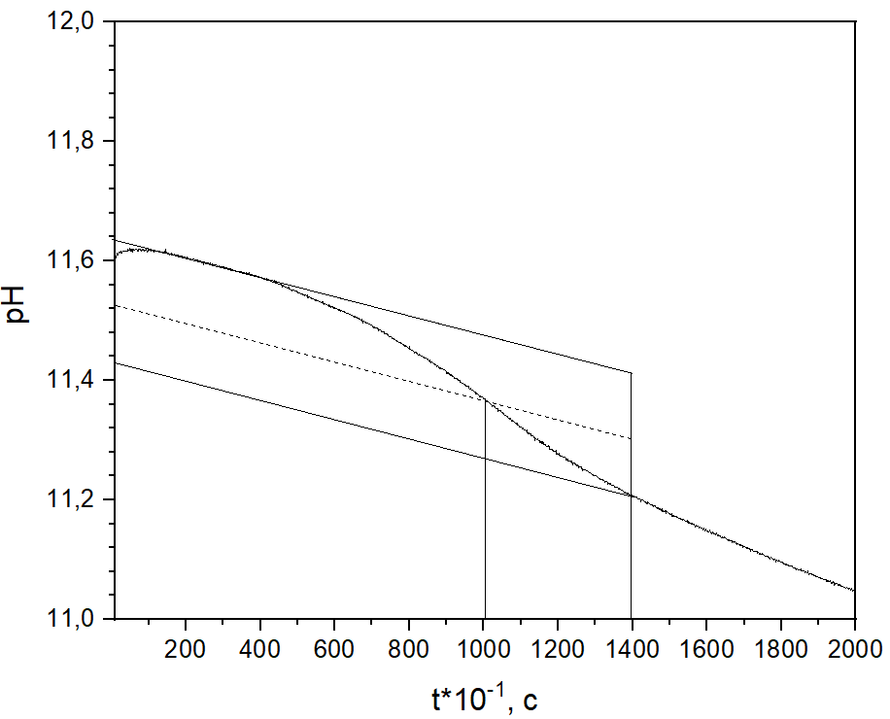  h

Fig. S2. Variation of pH with time for the samples: a – ac, b – mg, c – cit, d – pp, e – suc, f – mg+pp, g – tm, h – tp
Рис. S2. Изменение pH для образцов: a – ac, b – mg, c – cit, d – pp, e – suc, f – mg+pp, g – tm, h – tp
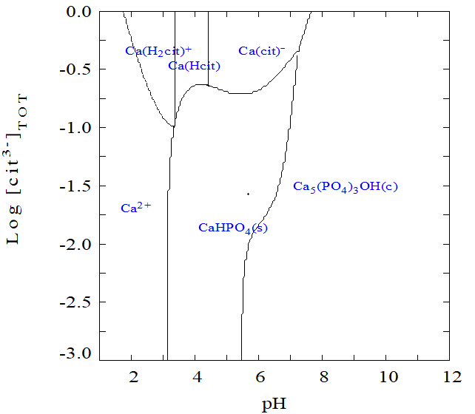  a | 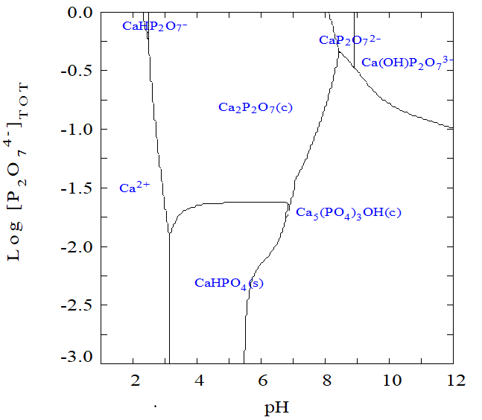  b | 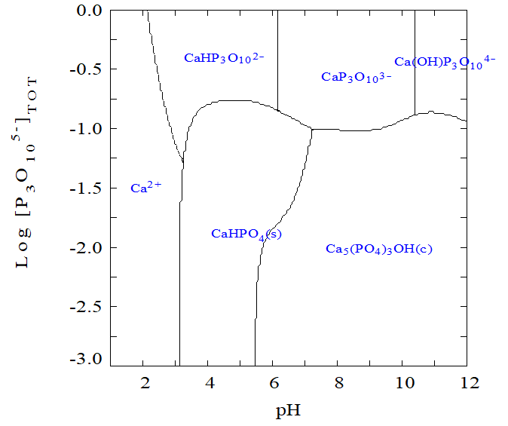  c
d  h | 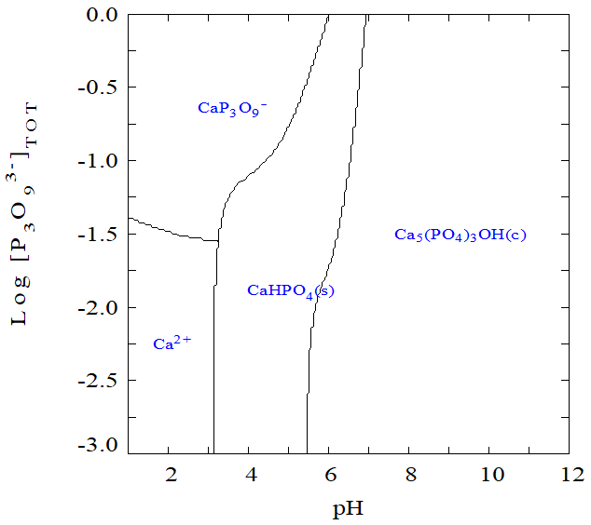  f  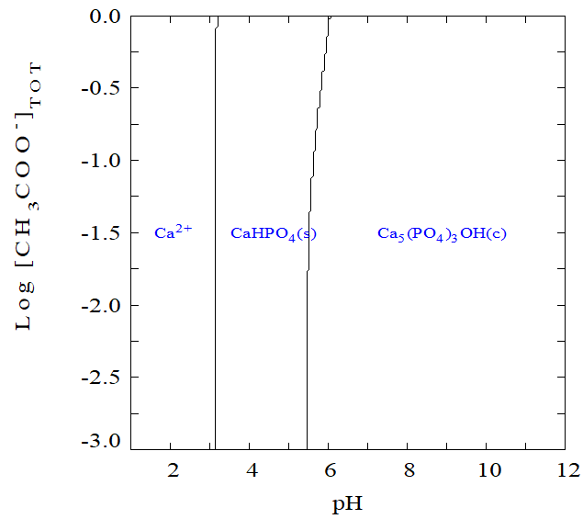  i | 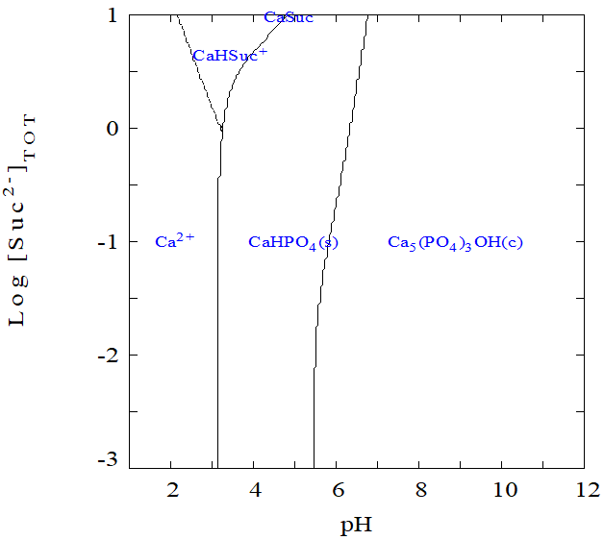  g  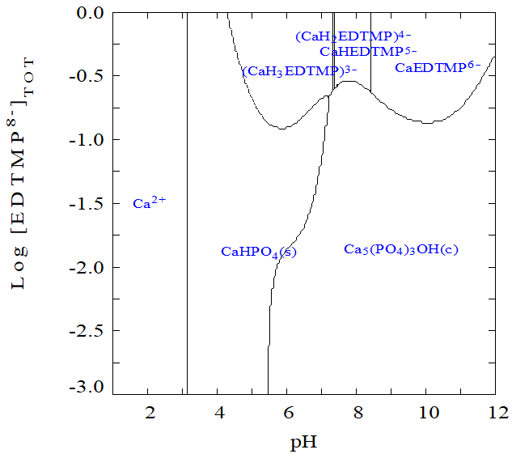  j
Fig. S3. Diagrams of predominant ionic forms/solid phases for the systems Са²⁺ - РО₄³⁻ - Х^{n-} – Н⁺ ( [Ca²⁺]=75 mМ, [PO₄³⁻]=50 mМ) lg[X] – рН for Х^{n-}: a – cit³⁻, b – Р₂О₇⁴⁻, c – Р₃О₁₀⁵⁻, d – mal²⁻, e – P₃O₉³⁻, f – suc²⁻, h – PO₄³⁻, i – ac⁻, j – EDTMP⁸⁻
Рис. S3. Диаграммы преимущественных ионных форм/твердых фаз для систем Са²⁺ - РО₄³⁻ - Х^{n-} – Н⁺ ( [Ca²⁺]=75 мМ, [PO₄³⁻]=50 мМ) в координатах lg[X] – рН для Х^{n-}: a – cit³⁻, b – Р₂О₇⁴⁻, c – Р₃О₁₀⁵⁻, d – mal²⁻, e – P₃O₉³⁻, f – suc²⁻, h – PO₄³⁻, i – ac⁻, j – EDTMP⁸⁻
IR spectroscopy
IR spectroscopy was carried out to assess the composition of the obtained samples. It can be concluded that for each of the samples, all vibrations corresponding to the phosphates functional groups were found, as well as vibrations caused by the presence of crystal water in the structure. Also, in the first and fourth spectra, the peaks corresponding to pyrophosphate ions can be seen.
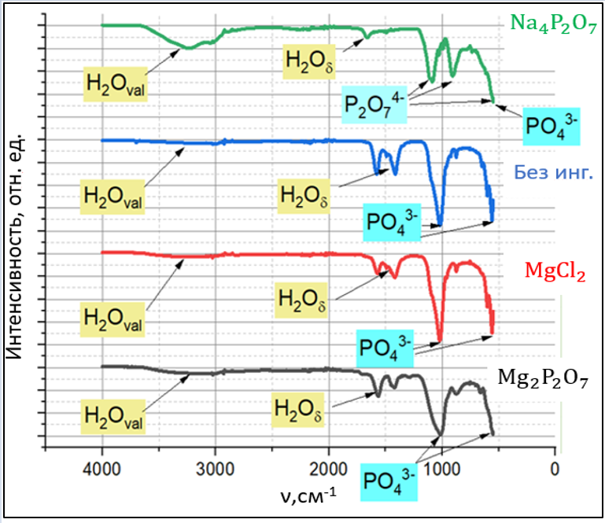
Fig. S4. IR spectra of some ACP samples
Рис. S4. ИК-спектры некоторых образцов АФК

Thermogravimetric Analysis
Using the obtained results, it is possible to determine firing temperature and to formulate recommendations for firing of ceramics after 3D printing. So, e.g., for the first sample (Fig.S5 a), it can be seen that after reaching the temperature of 860-870°C, no further change in mass occurs, and, therefore, no processes (such as dehydration, i.e. removal of crystallization water) go further.
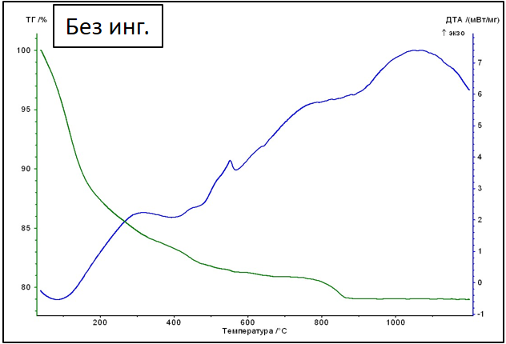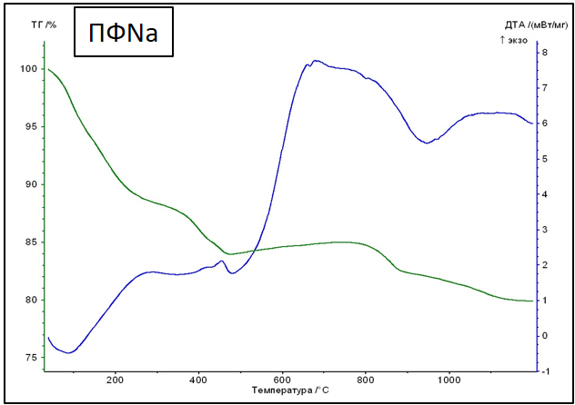
Fig. S5. TGA/DTA of АСР samples: a - 0, b – pp
Рис. S5. TГ/ДТА кривые образцов АФК a - 0, b – pp
Therefore, it is possible to set the calcination temperature at ≥900°. For the second sample (sodium pyrophosphate as an inhibitor), the end of the change in mass in the case of the second sample occurs at a temperature of about 1200°C.
SEM data
After firing, crystallites up to 10 μm in size were formed, in some cases, they have an elongated shape.
Table S1. SEM images of the powders before firing
Таблица S1. Данные РЭМ порошков до обжига
0 | ac | cit
mal | mg+pp | mg
pp | suc | tm
 | tp
Table S2. SEM images of the powders after firing at 900°C
Таблица S2. Данные РЭМ порошков после обжига при 900°C
mg | ac | cit
mg+cit | suc | mg+ac

