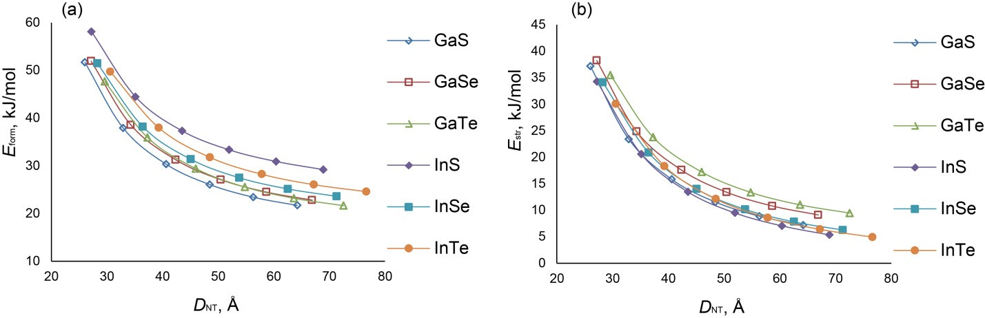

Quantum chemical simulation of double-walled nanotubes based on

gallium and indium chalcogenides

Russian Journal of Inorganic Chemistry

Andrei V. Bandura*, Dmitry D. Kuruch, Sergey I. Lukyanov, Robert A. Evarestov

Quantum Chemistry Department, Institute of Chemistry, Saint-Petersburg State University

7/9 Universitetskaya nab., St. Petersburg, 199034, Russia

*Corresponding author, email: [a.bandura@spbu.ru](mailto:a.bandura@spbu.ru)

*Supplementary materials*

**Figure S1.** Dependence of formation energy (a) and strain energy (b) of single- walled armchair

nanotubes on average diameter *D*NT. The nanotubes are rolled up from (001) monolayers of hexagonal (*P*63/*mmc*) МХ phases (M = Ga, In; X = S, Se, Te).

1

**Table S1.** Calculated properties of double-walled nanotubes: interwall distance Δ*R*NT\**,* average diameter *D*NT, formation energy *E*form, binding energy *E*bind, and electron band gap *E*gap.

kJ/mole

*Interwall distance Δ*R*NT is calculated as the difference between the average radius *R*NT2 of external single-walled component and the average radius *R*NT1 of internal single-walled component.

2

Compound

Double-wall nanotube chirality

*D*NT, Å

Δ*R*NT, Å

*E*form, kJ/mole

*E*bind,

*E*gap, eV

GaS

(14, 14)@(21, 21)

36.1

7.6

29.7

-5.31

2.47

(16, 16)@(24, 24)

40.7

7.8

24.5

-6.34

2.71

(18, 18)@(27, 27)

45.5

7.9

22.1

-5.67

2.78

(20, 20)@(30, 30)

50.3

7.9

21.6

-4.03

2.80

(24, 0)@(36, 0)

36.2

7.6

29.0

-6.04

2.29

(26, 0)@(39, 0)

38.8

7.6

25.4

-7.03

2.45

(28, 0)@(42, 0)

41.4

7.7

23.1

-7.23

2.54

(30, 0)@(45, 0)

44.1

7.8

21.7

-6.86

2.58

GaTe

(16, 16)@(24, 24)

46.2

8.7

24.3

-6.80

1.74

(28, 0)@(42, 0)

46.9

8.7

23.4

-7.31

1.53

InS

(14, 14)@(21, 21)

38.6

8.0

35.5

-6.18

1.57

(16, 16)@(24, 24)

43.7

8.2

31.1

-6.65

1.83

(18, 18)@(27, 27)

48.8

8.3

29.1

-5.91

1.95

(24, 0)@(36, 0)

38.8

8.0

34.3

-7.23

1.55

(26, 0)@(39, 0)

41.6

8.0

31.3

-7.81

1.71

(28, 0)@(42, 0)

44.5

8.1

29.4

-7.75

1.82

(30, 0)@(45, 0)

47.4

8.2

28.2

-7.29

1.88

InTe

(14, 14)@(21, 21)

43.3

9.0

29.0

-6.53

0.86

(16, 16)@(24, 24)

48.8

9.2

24.9

-7.26

1.29

(18, 18)@(27, 27)

54.4

9.3

23.0

-6.65

1.47

(26, 0)@(39, 0)

46.4

9.0

25.5

-7.74

1.14

(28, 0)@(42, 0)

49.6

9.1

23.7

-7.84

1.38

(30, 0)@(45, 0)

54.8

9.2

22.7

-7.50

1.46

Ga2STe

(14, 14)@(21, 21)

37.7

8.1

18.7

-5.10

1.81

(16, 16)@(24, 24)

42.6

8.3

16.5

-6.13

1.73

(18, 18)@(27, 27)

47.6

8.4

16.7

-5.47

1.69

(20, 20)@(30, 30)

52.8

8.5

18.1

-3.84

1.65

(26, 0)@(39, 0)

40.5

8.2

16.3

-6.74

1.70

(28, 0)@(42, 0)

43.3

8.2

15.7

-6.94

1.88

(30, 0)@(45, 0)

46.2

8.3

15.7

-6.58

2.03

In2STe

(14, 14)@(21, 21)

40.2

8.6

21.4

-5.68

1.47

(16, 16)@(24, 24)

45.5

8.8

19.3

-6.46

1.68

(18, 18)@(27, 27)

50.9

8.9

19.3

-5.77

1.76

(24, 0)@(36, 0)

40.3

8.5

20.6

-6.57

1.48

(26, 0)@(39, 0)

43.3

8.6

19.0

-7.30

1.62

(28, 0)@(42, 0)

46.3

8.7

18.3

-7.39

1.72

(30, 0)@(45, 0)

49.5

8.7

18.3

-6.95

1.78