checkCIF/PLATON report

Structure factors have been supplied for datablock(s) 1915_0m_a

THIS REPORT IS FOR GUIDANCE ONLY. IF USED AS PART OF A REVIEW PROCEDURE FOR PUBLICATION, IT SHOULD NOT REPLACE THE EXPERTISE OF AN EXPERIENCED CRYSTALLOGRAPHIC REFEREE.

No syntax errors found. CIF dictionary Interpreting this report

Datablock: 1915_0m_a

Bond precision: C-C = 0.0145 A Wavelength=0.71073

Cell: | a=13.776(11) | b=20.592(19) | c=12.408(13)
 | alpha=90 | beta=121.73(4) | gamma=90
Temperature: | 293 K

Calculated Reported Volume 2994(5) 2994(5) Space group C 2/c C 1 2/c 1
Hall group -C 2yc -C 2yc
Moiety formula C36 H25 Bi O4 C36 H25 Bi O4
Sum formula C36 H25 Bi O4 C36 H25 Bi O4
Mr 730.54 730.54
Dx,g cm-3 1.621 1.621
Z 4 4
Mu (mm-1) 5.926 5.927
F000 1424.0 1424.0
F000’ 1408.51
h,k,lmax 18,27,16 18,27,16
Nref 3585 3569
Tmin,Tmax 0.030,0.888 0.297,0.746
Tmin’ 0.015

Correction method= # Reported T Limits: Tmin=0.297 Tmax=0.746
AbsCorr = MULTI-SCAN

Data completeness= 0.996 Theta(max)= 27.890
R(reflections)= 0.0433( 3332) wR2(reflections)= 0.1267( 3569) S = 1.068 Npar= 187

The following ALERTS were generated. Each ALERT has the format
test-name_ALERT_alert-type_alert-level.
Click on the hyperlinks for more details of the test.

Alert level C
PLAT148_ALERT_3_C s.u. on the c - Axis is (Too) Large .... 0.013 Ang. PLAT241_ALERT_2_C High ’MainMol’ Ueq as Compared to Neighbors of C13 Check PLAT242_ALERT_2_C Low ’MainMol’ Ueq as Compared to Neighbors of C11 Check PLAT342_ALERT_3_C Low Bond Precision on C-C Bonds ............... 0.01447 Ang. PLAT972_ALERT_2_C Check Calcd Resid. Dens. 0.87A From Bi1 -2.14 eA-3
PLAT972_ALERT_2_C Check Calcd Resid. Dens. 1.05A From Bi1 -1.76 eA-3
PLAT975_ALERT_2_C Check Calcd Resid. Dens. 0.75A From O1 0.52 eA-3
PLAT977_ALERT_2_C Check Negative Difference Density on H14 -0.41 eA-3

Alert level G
PLAT012_ALERT_1_G No _shelx_res_checksum Found in CIF ...... Please Check PLAT063_ALERT_4_G Crystal Size Possibly too Large for Beam Size .. 0.65 mm PLAT083_ALERT_2_G SHELXL Second Parameter in WGHT Unusually Large 29.41 Why ? PLAT128_ALERT_4_G Alternate Setting for Input Space Group C2/c I2/a Note PLAT199_ALERT_1_G Reported _cell_measurement_temperature ..... (K) 293 Check PLAT200_ALERT_1_G Reported _diffrn_ambient_temperature ..... (K) 293 Check PLAT371_ALERT_2_G Long C(sp2)-C(sp1) Bond C21 - C27 . 1.45 Ang. PLAT371_ALERT_2_G Long C(sp2)-C(sp1) Bond C28 - C29 . 1.46 Ang. PLAT710_ALERT_4_G Delete 1-2-3 or 2-3-4 Linear Torsion Angle ... # 6 Do !
O1 -BI1 -O1 -C29 -179.00 0.50 2.555 1.555 1.555 1.555
PLAT710_ALERT_4_G Delete 1-2-3 or 2-3-4 Linear Torsion Angle ... # 15 Do !
O1 -C29 -C28 -C27 84.00 13.00 1.555 1.555 1.555 1.555
PLAT710_ALERT_4_G Delete 1-2-3 or 2-3-4 Linear Torsion Angle ... # 16 Do !
O2 -C29 -C28 -C27 -96.00 13.00 1.555 1.555 1.555 1.555
PLAT710_ALERT_4_G Delete 1-2-3 or 2-3-4 Linear Torsion Angle ... # 30 Do !
C29 -C28 -C27 -C21 7.00 26.00 1.555 1.555 1.555 1.555
PLAT710_ALERT_4_G Delete 1-2-3 or 2-3-4 Linear Torsion Angle ... # 31 Do !
C28 -C27 -C21 -C26 -74.00 15.00 1.555 1.555 1.555 1.555
PLAT710_ALERT_4_G Delete 1-2-3 or 2-3-4 Linear Torsion Angle ... # 32 Do !
C28 -C27 -C21 -C22 104.00 15.00 1.555 1.555 1.555 1.555
PLAT910_ALERT_3_G Missing # of FCF Reflection(s) Below Theta(Min). 4 Note PLAT912_ALERT_4_G Missing # of FCF Reflections Above STh/L= 0.600 13 Note PLAT941_ALERT_3_G Average HKL Measurement Multiplicity ........... 1.0 Low PLAT978_ALERT_2_G Number C-C Bonds with Positive Residual Density. 0 Info

0 ALERT level A = Most likely a serious problem - resolve or explain
0 ALERT level B = A potentially serious problem, consider carefully
8 ALERT level C = Check. Ensure it is not caused by an omission or oversight
18 ALERT level G = General information/check it is not something unexpected

3 ALERT type 1 CIF construction/syntax error, inconsistent or missing data
10 ALERT type 2 Indicator that the structure model may be wrong or deficient
4 ALERT type 3 Indicator that the structure quality may be low
9 ALERT type 4 Improvement, methodology, query or suggestion
0 ALERT type 5 Informative message, check

It is advisable to attempt to resolve as many as possible of the alerts in all categories. Often the minor alerts point to easily fixed oversights, errors and omissions in your CIF or refinement strategy, so attention to these fine details can be worthwhile. In order to resolve some of the more serious problems it may be necessary to carry out additional measurements or structure refinements. However, the purpose of your study may justify the reported deviations and the more
serious of these should normally be commented upon in the discussion or experimental section of a paper or in the "special_details" fields of the CIF. checkCIF was carefully designed to identify outliers and unusual parameters, but every test has its limitations and alerts that are not important
in a particular case may appear. Conversely, the absence of alerts does not guarantee there are no aspects of the results needing attention. It is up to the individual to critically assess their own results and, if necessary, seek expert advice.

Publication of your CIF in IUCr journals

A basic structural check has been run on your CIF. These basic checks will be run on all CIFs submitted for publication in IUCr journals (Acta Crystallographica, Journal of Applied Crystallography, Journal of Synchrotron Radiation); however, if you intend to submit to Acta Crystallographica Section C or E or IUCrData, you should make sure that full publication checks are run on the final version of your CIF prior to submission.

Publication of your CIF in other journals

Please refer to the Notes for Authors of the relevant journal for any special instructions relating to
CIF submission.

PLATON version of 18/09/2020; check.def file version of 20/08/2020

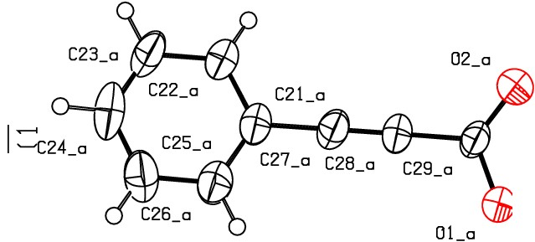Datablock 1915_0m_a- ellipsoid plot

>­
lf)

0
N
m
0
ro
NOMOVE FORCED Prob
Temp

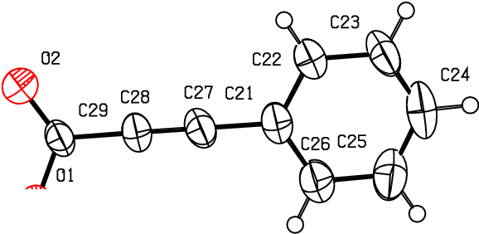cs ?

C6 :ml·Q7C5 a
Cl_a llC4_a
C4 r 'j' Cl
--L»l'1
Hr.)--, 'll' o.
50
293

0 BLl
C3 }

N
0
N
m
(Y..)
r-­
lf)

lf)
0
N
C3_a C2 dSC2_a

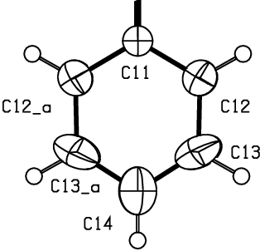>
0
.z
I
.z
0
f­
a:
_j
o_

z 0 1915 Om a C 1 2/c 1

R 0.04

RES= 0 0 X

