checkCIF/PLATON report

You have not supplied any structure factors. As a result the full set of tests cannot be run.

THIS REPORT IS FOR GUIDANCE ONLY. IF USED AS PART OF A REVIEW PROCEDURE FOR PUBLICATION, IT SHOULD NOT REPLACE THE EXPERTISE OF AN EXPERIENCED CRYSTALLOGRAPHIC REFEREE.

No syntax errors found. CIF dictionary Interpreting this report

Datablock: 1934_0m_a

Bond precision: C-C = 0.0098 A Wavelength=0.71073

Cell: | a=12.456(8) | b=12.713(9) | c=13.357(9)
 | alpha=86.23(3) | beta=71.82(3) | gamma=69.78(2)
Temperature: | 293 K

Calculated Reported Volume 1884(2) 1884(2) Space group P -1 P -1
Hall group -P 1 -P 1
Moiety formula C32 H21 Bi N4 O12, C6 H6 C32 H21 Bi N4 O12, 1(C6
H6)
Sum formula C38 H27 Bi N4 O12 C38 H27 Bi N4 O12
Mr 940.62 940.61
Dx,g cm-3 | 1.658 | 1.659
Z | 2 | 2
Mu (mm-1) | 4.748 | 4.749
F000 | 924.0 | 924.0
F000’ | 916.36
h,k,lmax | 15,15,16 | 14,15,16
Nref | 6918 | 6845
Tmin,Tmax | 0.510,0.593 | 0.576,0.745
Tmin’ | 0.238

Correction method= # Reported T Limits: Tmin=0.576 Tmax=0.745
AbsCorr = MULTI-SCAN

Data completeness= 0.989 Theta(max)= 25.390

R(reflections)= 0.0373( 5297) wR2(reflections)= 0.0874( 6845) S = 1.050 Npar= 479

The following ALERTS were generated. Each ALERT has the format
test-name_ALERT_alert-type_alert-level.
Click on the hyperlinks for more details of the test.

Alert level C
PLAT094_ALERT_2_C Ratio of Maximum / Minimum Residual Density .... 3.14 Report PLAT234_ALERT_4_C Large Hirshfeld Difference C13 --C14 . 0.16 Ang. PLAT234_ALERT_4_C Large Hirshfeld Difference C15 --C16 . 0.16 Ang. PLAT241_ALERT_2_C High ’MainMol’ Ueq as Compared to Neighbors of O2 Check PLAT241_ALERT_2_C High ’MainMol’ Ueq as Compared to Neighbors of C23 Check PLAT242_ALERT_2_C Low ’MainMol’ Ueq as Compared to Neighbors of N1 Check PLAT242_ALERT_2_C Low ’MainMol’ Ueq as Compared to Neighbors of N2 Check PLAT242_ALERT_2_C Low ’MainMol’ Ueq as Compared to Neighbors of N3 Check PLAT242_ALERT_2_C Low ’MainMol’ Ueq as Compared to Neighbors of C21 Check PLAT250_ALERT_2_C Large U3/U1 Ratio for Average U(i,j) Tensor .... 2.4 Note PLAT250_ALERT_2_C Large U3/U1 Ratio for Average U(i,j) Tensor .... 2.4 Note PLAT260_ALERT_2_C Large Average Ueq of Residue Including C51B 0.102 Check PLAT260_ALERT_2_C Large Average Ueq of Residue Including C51A 0.102 Check PLAT331_ALERT_2_C Small Aver Phenyl C-C Dist C11 --C16 . 1.36 Ang. PLAT334_ALERT_2_C Small Aver. Benzene C-C Dist C31 -C36 1.37 Ang. PLAT342_ALERT_3_C Low Bond Precision on C-C Bonds ............... 0.00984 Ang.

Alert level G
PLAT003_ALERT_2_G Number of Uiso or Uij Restrained non-H Atoms ... 6 Report PLAT042_ALERT_1_G Calc. and Reported Moiety Formula Strings Differ Please Check PLAT171_ALERT_4_G The CIF-Embedded .res File Contains EADP Records 6 Report PLAT178_ALERT_4_G The CIF-Embedded .res File Contains SIMU Records 1 Report PLAT186_ALERT_4_G The CIF-Embedded .res File Contains ISOR Records 1 Report PLAT199_ALERT_1_G Reported _cell_measurement_temperature ..... (K) 293 Check PLAT200_ALERT_1_G Reported _diffrn_ambient_temperature ..... (K) 293 Check PLAT302_ALERT_4_G Anion/Solvent/Minor-Residue Disorder (Resd 2 ) 100% Note PLAT302_ALERT_4_G Anion/Solvent/Minor-Residue Disorder (Resd 3 ) 100% Note PLAT304_ALERT_4_G Non-Integer Number of Atoms in ..... (Resd 2 ) 6.29 Check PLAT304_ALERT_4_G Non-Integer Number of Atoms in ..... (Resd 3 ) 5.71 Check PLAT860_ALERT_3_G Number of Least-Squares Restraints ............. 72 Note PLAT883_ALERT_1_G No Info/Value for _atom_sites_solution_primary . Please Do ! PLAT933_ALERT_2_G Number of OMIT Records in Embedded .res File ... 4 Note

0 ALERT level A = Most likely a serious problem - resolve or explain
0 ALERT level B = A potentially serious problem, consider carefully
16 ALERT level C = Check. Ensure it is not caused by an omission or oversight
14 ALERT level G = General information/check it is not something unexpected

4 ALERT type 1 CIF construction/syntax error, inconsistent or missing data
15 ALERT type 2 Indicator that the structure model may be wrong or deficient
2 ALERT type 3 Indicator that the structure quality may be low
9 ALERT type 4 Improvement, methodology, query or suggestion
0 ALERT type 5 Informative message, check

It is advisable to attempt to resolve as many as possible of the alerts in all categories. Often the minor alerts point to easily fixed oversights, errors and omissions in your CIF or refinement strategy, so attention to these fine details can be worthwhile. In order to resolve some of the more serious problems it may be necessary to carry out additional measurements or structure refinements. However, the purpose of your study may justify the reported deviations and the more
serious of these should normally be commented upon in the discussion or experimental section of a paper or in the "special_details" fields of the CIF. checkCIF was carefully designed to identify outliers and unusual parameters, but every test has its limitations and alerts that are not important
in a particular case may appear. Conversely, the absence of alerts does not guarantee there are no aspects of the results needing attention. It is up to the individual to critically assess their own results and, if necessary, seek expert advice.

Publication of your CIF in IUCr journals

A basic structural check has been run on your CIF. These basic checks will be run on all CIFs submitted for publication in IUCr journals (Acta Crystallographica, Journal of Applied Crystallography, Journal of Synchrotron Radiation); however, if you intend to submit to Acta Crystallographica Section C or E or IUCrData, you should make sure that full publication checks are run on the final version of your CIF prior to submission.

Publication of your CIF in other journals

Please refer to the Notes for Authors of the relevant journal for any special instructions relating to
CIF submission.

PLATON version of 22/03/2021; check.def file version of 19/03/2021

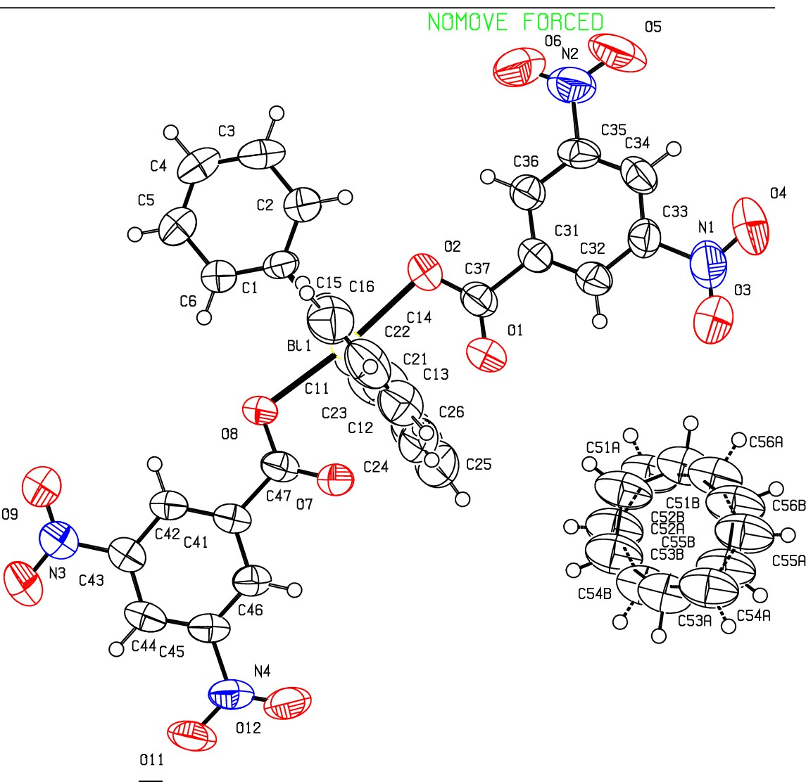Datablock 1934_0m_a- ellipsoid plot

>- Prob
Temp
50
293

(Y)
I

N
(Y)
0
N
N

N
0
N
m
..
0
0
(X)
0

£- 010
L
I
:z:
0
f­
a:
_j
o_

z 128 1934 Om a

p -1

R 0.04

RES= 0-117 X

