checkCIF/PLATON report

You have not supplied any structure factors. As a result the full set of tests cannot be run.

THIS REPORT IS FOR GUIDANCE ONLY. IF USED AS PART OF A REVIEW PROCEDURE FOR PUBLICATION, IT SHOULD NOT REPLACE THE EXPERTISE OF AN EXPERIENCED CRYSTALLOGRAPHIC REFEREE.

No syntax errors found. CIF dictionary Interpreting this report

Datablock: 1973_01_a

Bond precision: C-C = 0.0169 A Wavelength=0.71073

Cell: | a=19.002(2) | b=9.6147(4) | c=16.2574(6)
 | alpha=90 | beta=92.919(10) | gamma=90
Temperature: | 293 K

Calculated Reported Volume 2966.4(4) 2966.3(4) Space group C 2/c C 1 2/c 1
Hall group -C 2yc -C 2yc
Moiety formula C34 H29 Bi O6 C34 H29 Bi O6
Sum formula C34 H29 Bi O6 C34 H29 Bi O6
Mr 742.55 742.55
Dx,g cm-3 1.663 1.663
Z 4 4
Mu (mm-1) 5.988 5.988
F000 1456.0 1456.0
F000’ 1440.56
h,k,lmax 24,12,21 24,12,21
Nref 3455 3426
Tmin,Tmax 0.093,0.698 0.412,0.746
Tmin’ 0.018

Correction method= # Reported T Limits: Tmin=0.412 Tmax=0.746
AbsCorr = MULTI-SCAN

Data completeness= 0.992 Theta(max)= 27.608
R(reflections)= 0.0606( 3151) wR2(reflections)= 0.1551( 3426) S = 1.151 Npar= 188

The following ALERTS were generated. Each ALERT has the format
test-name_ALERT_alert-type_alert-level.
Click on the hyperlinks for more details of the test.

Alert level C
PLAT220_ALERT_2_C NonSolvent Resd 1 C Ueq(max)/Ueq(min) Range 3.3 Ratio PLAT234_ALERT_4_C Large Hirshfeld Difference C9 --C10 . 0.21 Ang. PLAT241_ALERT_2_C High ’MainMol’ Ueq as Compared to Neighbors of O1 Check PLAT241_ALERT_2_C High ’MainMol’ Ueq as Compared to Neighbors of C3 Check PLAT241_ALERT_2_C High ’MainMol’ Ueq as Compared to Neighbors of C15 Check PLAT242_ALERT_2_C Low ’MainMol’ Ueq as Compared to Neighbors of C12 Check PLAT331_ALERT_2_C Small Aver Phenyl C-C Dist C7 --C8_a . 1.37 Ang. PLAT342_ALERT_3_C Low Bond Precision on C-C Bonds ............... 0.01688 Ang.

Alert level G
PLAT063_ALERT_4_G Crystal Size Possibly too Large for Beam Size .. 0.65 mm PLAT083_ALERT_2_G SHELXL Second Parameter in WGHT Unusually Large 15.68 Why ? PLAT199_ALERT_1_G Reported _cell_measurement_temperature ..... (K) 293 Check PLAT200_ALERT_1_G Reported _diffrn_ambient_temperature ..... (K) 293 Check PLAT883_ALERT_1_G No Info/Value for _atom_sites_solution_primary . Please Do !

0 ALERT level A = Most likely a serious problem - resolve or explain
0 ALERT level B = A potentially serious problem, consider carefully
8 ALERT level C = Check. Ensure it is not caused by an omission or oversight
5 ALERT level G = General information/check it is not something unexpected

3 ALERT type 1 CIF construction/syntax error, inconsistent or missing data
7 ALERT type 2 Indicator that the structure model may be wrong or deficient
1 ALERT type 3 Indicator that the structure quality may be low
2 ALERT type 4 Improvement, methodology, query or suggestion
0 ALERT type 5 Informative message, check

It is advisable to attempt to resolve as many as possible of the alerts in all categories. Often the minor alerts point to easily fixed oversights, errors and omissions in your CIF or refinement strategy, so attention to these fine details can be worthwhile. In order to resolve some of the more serious problems it may be necessary to carry out additional measurements or structure refinements. However, the purpose of your study may justify the reported deviations and the more
serious of these should normally be commented upon in the discussion or experimental section of a paper or in the "special_details" fields of the CIF. checkCIF was carefully designed to identify outliers and unusual parameters, but every test has its limitations and alerts that are not important
in a particular case may appear. Conversely, the absence of alerts does not guarantee there are no aspects of the results needing attention. It is up to the individual to critically assess their own results and, if necessary, seek expert advice.

Publication of your CIF in IUCr journals

A basic structural check has been run on your CIF. These basic checks will be run on all CIFs submitted for publication in IUCr journals (Acta Crystallographica, Journal of Applied Crystallography, Journal of Synchrotron Radiation); however, if you intend to submit to Acta Crystallographica Section C or E or IUCrData, you should make sure that full publication checks are run on the final version of your CIF prior to submission.

Publication of your CIF in other journals

Please refer to the Notes for Authors of the relevant journal for any special instructions relating to
CIF submission.

PLATON version of 22/03/2021; check.def file version of 19/03/2021

Datablock 1973_01_a ·ellipsoid plot

>­
r-­ N I

N
(Y")
0
N
N

N
0
N
N
N..
CD
N
(X)
0
NOMOVE FORCED Prob
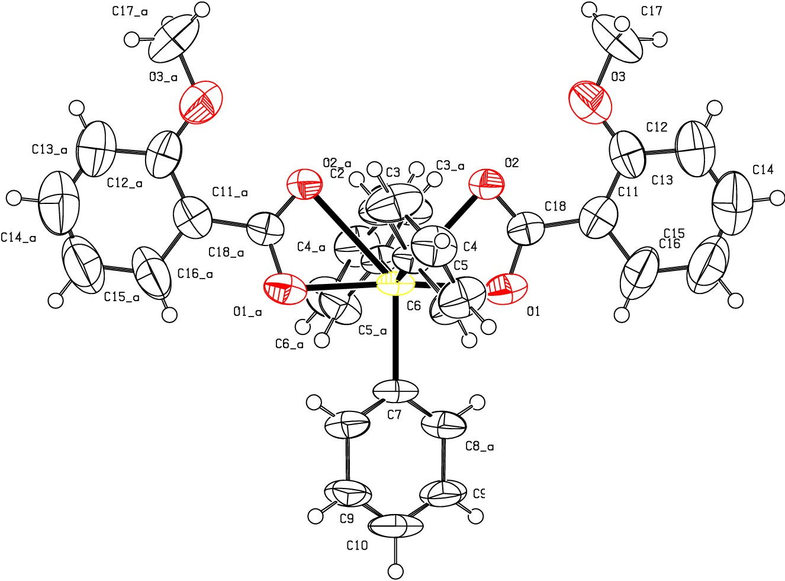Temp
50
293

L
Q_
CI
I
:z:
0
f­
CI
_j
o_

z 0
CB

1973 01 a C 1 2/c 1

C9_a

R 0.06 RES= 0 0 X

