Supplementary information

Extraction of REE(III) from nitric acid solutions with binary extractants based on dialkylamino derivatives of carbomaylmethylphosphine oxides and dinonylnaphthalene sulfonic acid

A.N. Turanov, V.K. Karandashev, O.I. Artyushin, E.V. Sharova, V.A. Khvostikov

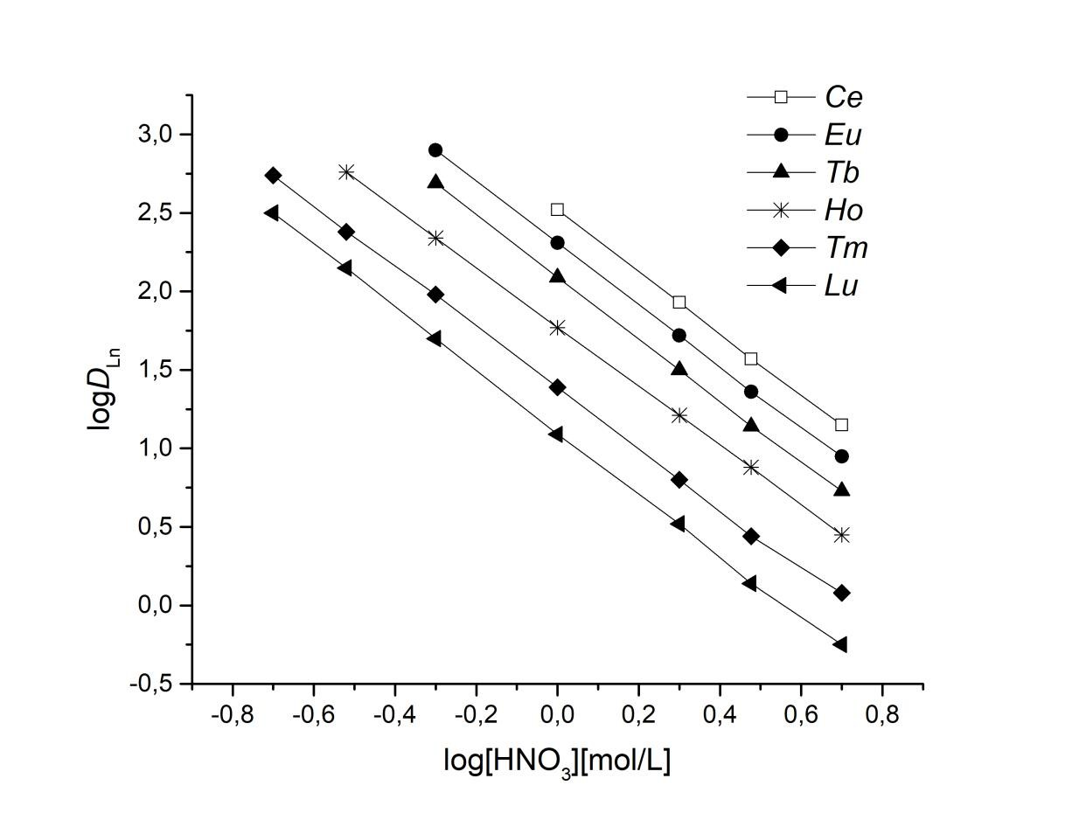Russian Journal of Inorganic Chemistry

Fig. S1. The effect of HNO3 concentration in the aqueous phase on the extraction of REE(III)
with 0.05 M solutions of L1HA in 1,2-dichloroethane.

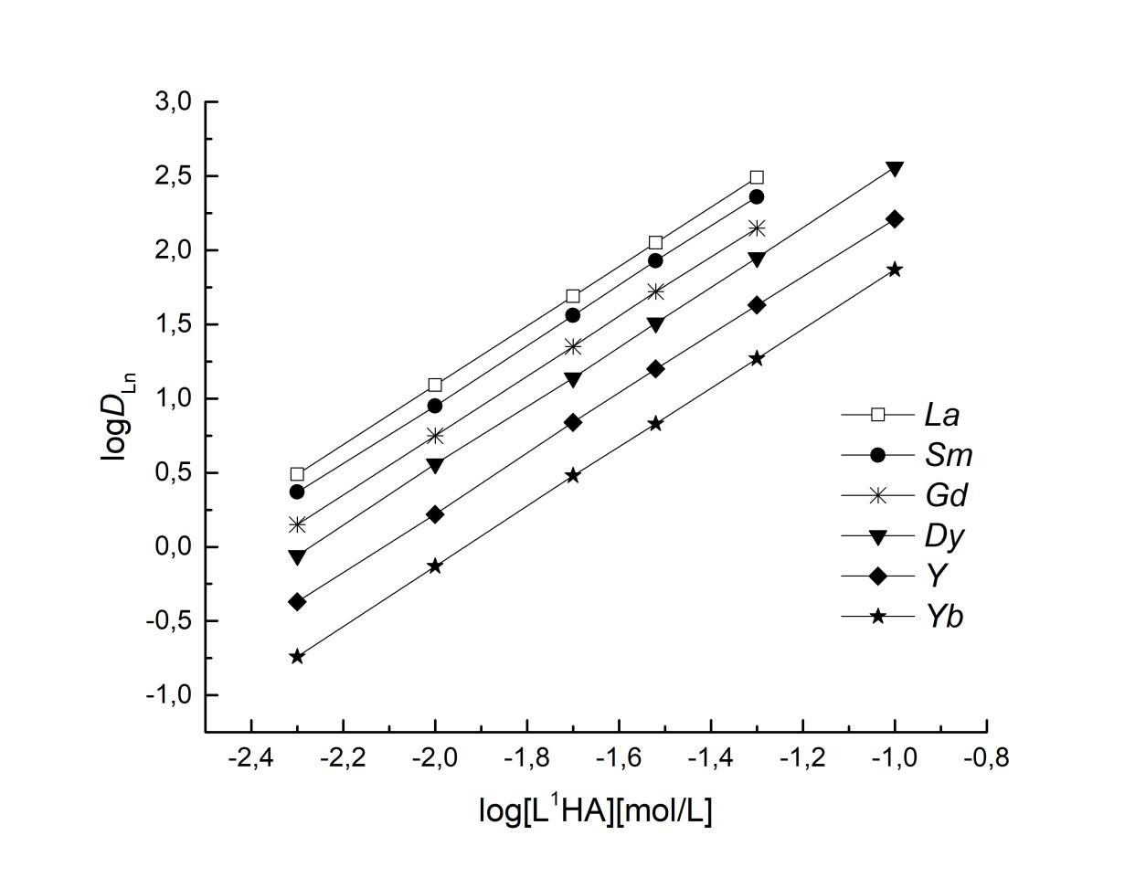

Fig. S2. The effect of binary extractant L1HA concentration in 1,2-dichloroethane on the extraction of REE(III) from 1 M HNO3 solutions.

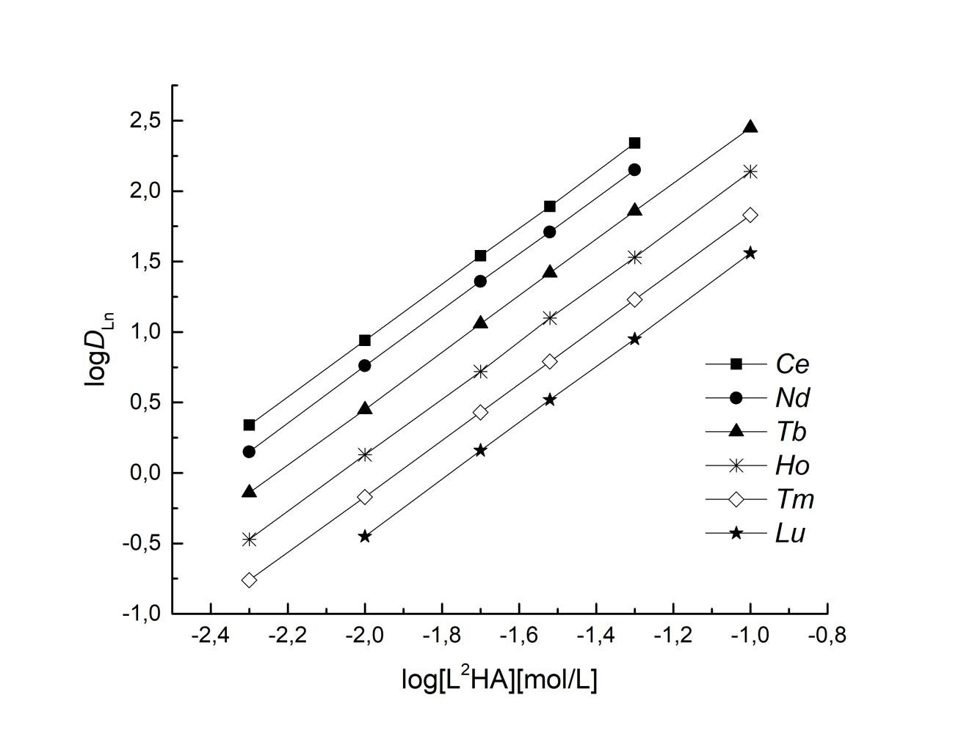

Fig. S3. The effect of binary extractant L2HA concentration in 1,2-dichloroethane on the extraction of REE(III) from 1 M HNO3 solutions.

