checkCIF/PLATON report

Structure factors have been supplied for datablock(s) 1080_0m_a

THIS REPORT IS FOR GUIDANCE ONLY. IF USED AS PART OF A REVIEW PROCEDURE FOR PUBLICATION, IT SHOULD NOT REPLACE THE EXPERTISE OF AN EXPERIENCED CRYSTALLOGRAPHIC REFEREE.

No syntax errors found. CIF dictionary Interpreting this report

Datablock: 1080_0m_a

Bond precision: C-C = 0.0095 A Wavelength=0.71073

Cell: | a=11.684(11) | b=12.639(11) | c=13.052(14)
 | alpha=61.88(3) | beta=63.33(4) | gamma=80.80(3)
Temperature: | 293 K

 | Calculated |  |  | Reported
Volume | 1516(3) |  |  | 1516(2)
Space group | P -1 |  |  | P -1
Hall group | -P 1 |  |  | -P 1
Moiety formula | C26 H12 F17 | O4 | Sb | C26 H12 F17 O4 Sb
Sum formula | C26 H12 F17 | O4 | Sb | C26 H12 F17 O4 Sb
Mr | 833.12 |  |  | 833.11
Dx,g cm-3 | 1.825 |  |  | 1.825
Z | 2 |  |  | 2
Mu (mm-1) | 1.046 |  |  | 1.047
F000 | 808.0 |  |  | 808.0
F000’ | 807.60
h,k,lmax | 17,19,19 |  |  | 17,19,19
Nref | 11358 |  |  | 11054
Tmin,Tmax | 0.441,0.551 |  |  | 0.453,0.587
Tmin’ | 0.386

Correction method= # Reported T Limits: Tmin=0.453 Tmax=0.587
AbsCorr = MULTI-SCAN

Data completeness= 0.973 Theta(max)= 32.940
R(reflections)= 0.0559( 8160) wR2(reflections)= 0.1743( 11054) S = 1.063 Npar= 434

The following ALERTS were generated. Each ALERT has the format
test-name_ALERT_alert-type_alert-level.
Click on the hyperlinks for more details of the test.

Alert level B
PLAT230_ALERT_2_B Hirshfeld Test Diff for F14 --C37 . 12.0 s.u. PLAT234_ALERT_4_B Large Hirshfeld Difference F15 --C38 . 0.27 Ang. PLAT242_ALERT_2_B Low ’MainMol’ Ueq as Compared to Neighbors of C33 Check

Alert level C
ABSTY02_ALERT_1_C An _exptl_absorpt_correction_type has been given without a literature citation. This should be contained in the
_exptl_absorpt_process_details field. Absorption correction given as multi-scan
PLAT029_ALERT_3_C _diffrn_measured_fraction_theta_full value Low . 0.973 Why? PLAT031_ALERT_4_C Refined Extinction Parameter Within Range ...... 3.000 Sigma PLAT148_ALERT_3_C s.u. on the c - Axis is (Too) Large .... 0.014 Ang. PLAT155_ALERT_4_C The Triclinic Unitcell is NOT Reduced .......... Please Do ! PLAT220_ALERT_2_C Non-Solvent Resd 1 C Ueq(max)/Ueq(min) Range 3.3 Ratio PLAT220_ALERT_2_C Non-Solvent Resd 1 F Ueq(max)/Ueq(min) Range 3.6 Ratio PLAT230_ALERT_2_C Hirshfeld Test Diff for F9 --C34 . 6.8 s.u. PLAT230_ALERT_2_C Hirshfeld Test Diff for O3 --C35 . 6.5 s.u. PLAT234_ALERT_4_C Large Hirshfeld Difference F13 --C37 . 0.19 Ang. PLAT234_ALERT_4_C Large Hirshfeld Difference F16 --C38 . 0.22 Ang. PLAT234_ALERT_4_C Large Hirshfeld Difference F17 --C38 . 0.18 Ang. PLAT234_ALERT_4_C Large Hirshfeld Difference C37 --C38 . 0.17 Ang. PLAT242_ALERT_2_C Low ’MainMol’ Ueq as Compared to Neighbors of C4 Check PLAT242_ALERT_2_C Low ’MainMol’ Ueq as Compared to Neighbors of C14 Check PLAT242_ALERT_2_C Low ’MainMol’ Ueq as Compared to Neighbors of C32 Check PLAT242_ALERT_2_C Low ’MainMol’ Ueq as Compared to Neighbors of C35 Check PLAT242_ALERT_2_C Low ’MainMol’ Ueq as Compared to Neighbors of C36 Check PLAT260_ALERT_2_C Large Average Ueq of Residue Including Sb1 0.121 Check PLAT342_ALERT_3_C Low Bond Precision on C-C Bonds ............... 0.0095 Ang. PLAT910_ALERT_3_C Missing # of FCF Reflection(s) Below Theta(Min). 8 Note PLAT911_ALERT_3_C Missing FCF Refl Between Thmin & STh/L= 0.600 6 Report PLAT973_ALERT_2_C Check Calcd Positive Resid. Density on Sb1 1.07 eA-3
PLAT978_ALERT_2_C Number C-C Bonds with Positive Residual Density. 0 Info

Alert level | G
PLAT012_ALERT_1_G | No | _shelx_res_checksum Found in CIF ...... | Please | Check
PLAT063_ALERT_4_G Crystal Size Likely too Large for Beam Size .... 0.90 mm
PLAT199_ALERT_1_G Reported _cell_measurement_temperature ..... (K) 293 Check PLAT200_ALERT_1_G Reported _diffrn_ambient_temperature ..... (K) 293 Check PLAT242_ALERT_2_G Low ’MainMol’ Ueq as Compared to Neighbors of C34 Check PLAT242_ALERT_2_G Low ’MainMol’ Ueq as Compared to Neighbors of C38 Check PLAT710_ALERT_4_G Delete 1-2-3 or 2-3-4 Linear Torsion Angle ... # 11 Do !
O1 -SB1 -O3 -C35 -117.00 13.00 1.555 1.555 1.555 1.555
PLAT710_ALERT_4_G Delete 1-2-3 or 2-3-4 Linear Torsion Angle ... # 21 Do !
O3 -SB1 -O1 -C31 1.00 14.00 1.555 1.555 1.555 1.555
PLAT912_ALERT_4_G Missing # of FCF Reflections Above STh/L= 0.600 293 Note PLAT933_ALERT_2_G Number of OMIT Records in Embedded .res File ... 6 Note PLAT992_ALERT_5_G Repd & Actual _reflns_number_gt Values Differ by 2 Check

0 ALERT level A = Most likely a serious problem - resolve or explain
3 ALERT level B = A potentially serious problem, consider carefully
24 ALERT level C = Check. Ensure it is not caused by an omission or oversight
11 ALERT level G = General information/check it is not something unexpected

4 ALERT type 1 CIF construction/syntax error, inconsistent or missing data

17 ALERT type 2 Indicator that the structure model may be wrong or deficient
5 ALERT type 3 Indicator that the structure quality may be low
11 ALERT type 4 Improvement, methodology, query or suggestion
1 ALERT type 5 Informative message, check

It is advisable to attempt to resolve as many as possible of the alerts in all categories. Often the minor alerts point to easily fixed oversights, errors and omissions in your CIF or refinement strategy, so attention to these fine details can be worthwhile. In order to resolve some of the more serious problems it may be necessary to carry out additional measurements or structure refinements. However, the purpose of your study may justify the reported deviations and the more
serious of these should normally be commented upon in the discussion or experimental section of a paper or in the "special_details" fields of the CIF. checkCIF was carefully designed to identify outliers and unusual parameters, but every test has its limitations and alerts that are not important
in a particular case may appear. Conversely, the absence of alerts does not guarantee there are no aspects of the results needing attention. It is up to the individual to critically assess their own results and, if necessary, seek expert advice.

Publication of your CIF in IUCr journals

A basic structural check has been run on your CIF. These basic checks will be run on all CIFs submitted for publication in IUCr journals (Acta Crystallographica, Journal of Applied Crystallography, Journal of Synchrotron Radiation); however, if you intend to submit to Acta Crystallographica Section C or E or IUCrData, you should make sure that full publication checks are run on the final version of your CIF prior to submission.

Publication of your CIF in other journals

Please refer to the Notes for Authors of the relevant journal for any special instructions relating to
CIF submission.

PLATON version of 07/08/2019; check.def file version of 30/07/2019

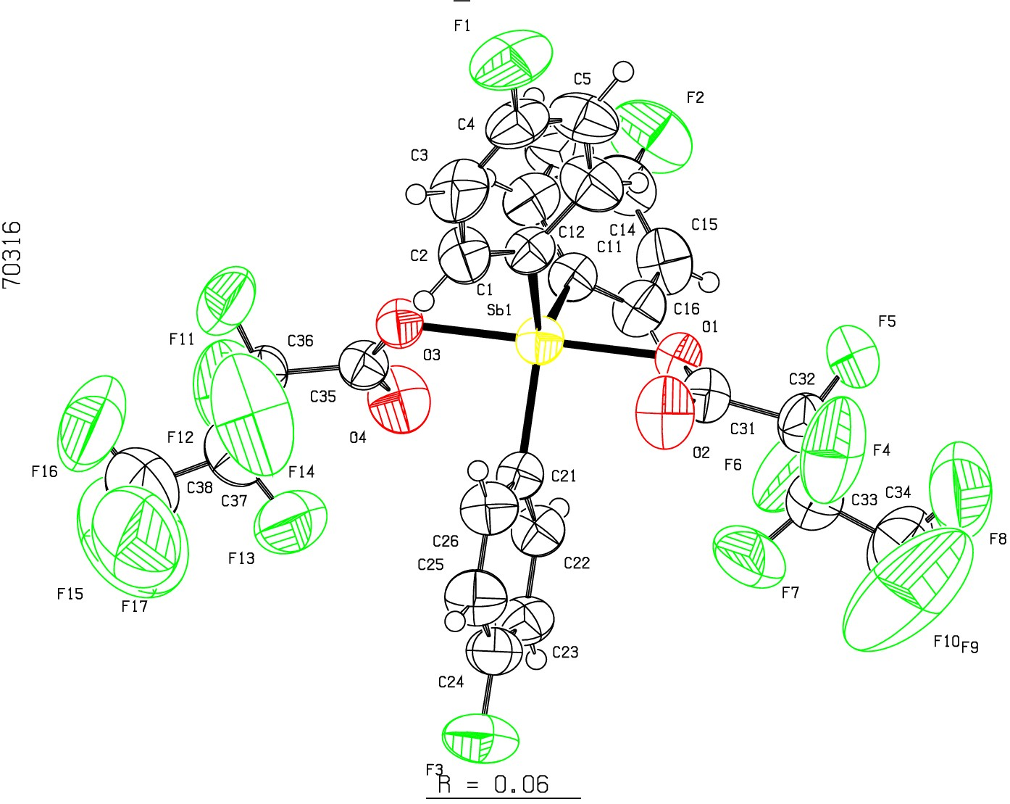Datablock 1080_0m_a- ellipsoid plot

>-
(Y)
N

m
0
N
CD
l.D.
0
N
r--
0
lD

u QJ D I
:z:
0
f­
a:
_j
o_
NOMOVE FORCED Prob
Temp
50
293

Z -106 1080_0m_a p -1 RES= 0
-39 X

