checkCIF/PLATON report

Structure factors have been supplied for datablock(s) 2014_0m_a_new

THIS REPORT IS FOR GUIDANCE ONLY. IF USED AS PART OF A REVIEW PROCEDURE FOR PUBLICATION, IT SHOULD NOT REPLACE THE EXPERTISE OF AN EXPERIENCED CRYSTALLOGRAPHIC REFEREE.

No syntax errors found. CIF dictionary Interpreting this report

Datablock: 2014_0m_a_new

Bond precision: C-C = 0.0043 A Wavelength=0.71073

Cell: | a=9.059(7) | b=11.775(9) | c=14.870(13)
 | alpha=69.37(6) | beta=89.61(2) | gamma=85.57(2)
Temperature: | 293 K

 | Calculated |  |  | Reported
Volume | 1480(2) |  |  | 1480(2)
Space group | P -1 |  |  | P -1
Hall group | -P 1 |  |  | -P 1
Moiety formula | C32 H14 F11 | O4 | Sb | C32 H14 F11 O4 Sb
Sum formula | C32 H14 F11 | O4 | Sb | C32 H14 F11 O4 Sb
Mr | 793.19 |  |  | 793.18
Dx,g cm-3 | 1.780 |  |  | 1.780
Z | 2 |  |  | 2
Mu (mm-1) | 1.040 |  |  | 1.040
F000 | 776.0 |  |  | 776.0
F000’ | 775.43
h,k,lmax | 15,19,24 |  |  | 15,19,24
Nref | 14502 |  |  | 14369
Tmin,Tmax | 0.819,0.856 |  |  | 0.630,0.860
Tmin’ | 0.601

Correction method= # Reported T Limits: Tmin=0.630 Tmax=0.860
AbsCorr = MULTI-SCAN

Data completeness= 0.991 Theta(max)= 36.468
R(reflections)= 0.0477( 9682) wR2(reflections)= 0.1033( 14369) S = 1.030 Npar= 443

The following ALERTS were generated. Each ALERT has the format
test-name_ALERT_alert-type_alert-level.
Click on the hyperlinks for more details of the test.

Alert level B
PLAT919_ALERT_3_B Reflection # Likely Affected by the Beamstop ... 1 Check

Alert level C
ABSTY02_ALERT_1_C An _exptl_absorpt_correction_type has been given without a literature citation. This should be contained in the
_exptl_absorpt_process_details field. Absorption correction given as multi-scan
PLAT213_ALERT_2_C Atom F10 has ADP max/min Ratio ..... 3.1 prolat PLAT242_ALERT_2_C Low ’MainMol’ Ueq as Compared to Neighbors of C36 Check PLAT434_ALERT_2_C Short Inter HL..HL Contact F1 ..F4B 2.50 Ang.
-1+x,y,z = 1_455 Check PLAT906_ALERT_3_C Large K Value in the Analysis of Variance ...... 6.098 Check PLAT910_ALERT_3_C Missing # of FCF Reflection(s) Below Theta(Min). 7 Note PLAT911_ALERT_3_C Missing FCF Refl Between Thmin & STh/L= 0.600 7 Report PLAT934_ALERT_3_C Number of (Iobs-Icalc)/Sigma(W) > 10 Outliers .. 1 Check PLAT973_ALERT_2_C Check Calcd Positive Resid. Density on Sb1 1.03 eA-3

Alert level G
PLAT199_ALERT_1_G Reported _cell_measurement_temperature ..... (K) 293 Check PLAT200_ALERT_1_G Reported _diffrn_ambient_temperature ..... (K) 293 Check PLAT301_ALERT_3_G Main Residue Disorder ..............(Resd 1 ) 2% Note PLAT912_ALERT_4_G Missing # of FCF Reflections Above STh/L= 0.600 119 Note PLAT933_ALERT_2_G Number of OMIT Records in Embedded .res File ... 5 Note PLAT978_ALERT_2_G Number C-C Bonds with Positive Residual Density. 10 Info PLAT992_ALERT_5_G Repd & Actual _reflns_number_gt Values Differ by 1 Check

0 ALERT level A = Most likely a serious problem - resolve or explain
1 ALERT level B = A potentially serious problem, consider carefully
9 ALERT level C = Check. Ensure it is not caused by an omission or oversight
7 ALERT level G = General information/check it is not something unexpected

3 ALERT type 1 CIF construction/syntax error, inconsistent or missing data
6 ALERT type 2 Indicator that the structure model may be wrong or deficient
6 ALERT type 3 Indicator that the structure quality may be low
1 ALERT type 4 Improvement, methodology, query or suggestion
1 ALERT type 5 Informative message, check

It is advisable to attempt to resolve as many as possible of the alerts in all categories. Often the minor alerts point to easily fixed oversights, errors and omissions in your CIF or refinement strategy, so attention to these fine details can be worthwhile. In order to resolve some of the more serious problems it may be necessary to carry out additional measurements or structure refinements. However, the purpose of your study may justify the reported deviations and the more
serious of these should normally be commented upon in the discussion or experimental section of a paper or in the "special_details" fields of the CIF. checkCIF was carefully designed to identify outliers and unusual parameters, but every test has its limitations and alerts that are not important
in a particular case may appear. Conversely, the absence of alerts does not guarantee there are no aspects of the results needing attention. It is up to the individual to critically assess their own results and, if necessary, seek expert advice.

Publication of your CIF in IUCr journals

A basic structural check has been run on your CIF. These basic checks will be run on all CIFs submitted for publication in IUCr journals (Acta Crystallographica, Journal of Applied Crystallography, Journal of Synchrotron Radiation); however, if you intend to submit to Acta Crystallographica Section C or E or IUCrData, you should make sure that full publication checks are run on the final version of your CIF prior to submission.

Publication of your CIF in other journals

Please refer to the Notes for Authors of the relevant journal for any special instructions relating to
CIF submission.

PLATON version of 07/08/2019; check.def file version of 30/07/2019

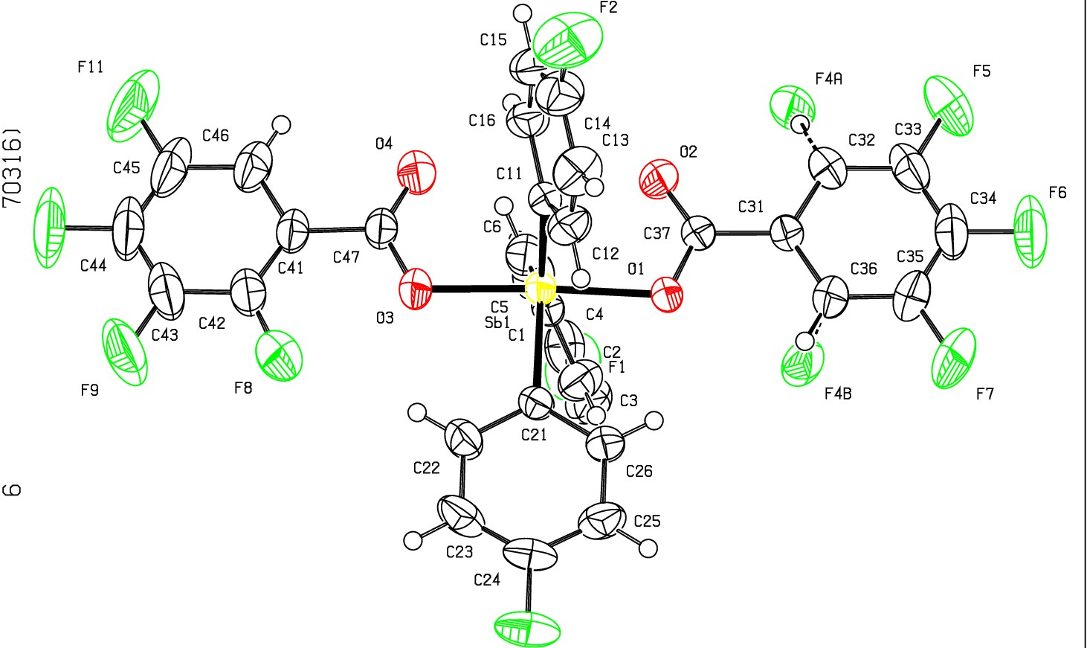Datablock 2014_0m_a_new ·ellipsoid plot

>­
...q­
tD

I
FlO
m
0
N

l.f .
"<t
o

u QJ D I
:z:
0
f­
a:
_j
o_ F3
NOMOVE FORCED Prob
Temp
50
293

z 23

2014 Om a P -1

R 0.05 RES= 0 68 X

