checkCIF/PLATON report

Structure factors have been supplied for datablock(s) 1238_0ma_b

THIS REPORT IS FOR GUIDANCE ONLY. IF USED AS PART OF A REVIEW PROCEDURE FOR PUBLICATION, IT SHOULD NOT REPLACE THE EXPERTISE OF AN EXPERIENCED CRYSTALLOGRAPHIC REFEREE.

No syntax errors found. CIF dictionary Interpreting this report

Datablock: 1238_0ma_b

Bond precision: C-C = 0.0137 A Wavelength=0.71073

Cell: | a=29.593(18) | b=9.374(4) | c=23.543(12)
 | alpha=90 | beta=130.124(19) | gamma=90
Temperature: | 293 K

Calculated Reported Volume 4994(5) 4994(4) Space group C 2 C 1 2 1
Hall group C 2y C 2y
Moiety formula 2(C26 H21 N P), Cl6 Hf 0.5(Cl6 Hf), C26 H21 N P
Sum formula | C52 H42 Cl6 Hf | N2 | P2 | C52 H42 Cl6 Hf N2 P2
Mr | 1148.01 |  |  | 1148.01
Dx,g cm-3 | 1.527 |  |  | 1.527
Z | 4 |  |  | 4
Mu (mm-1) | 2.511 |  |  | 2.511
F000 | 2288.0 |  |  | 4576.0
F000’ | 2290.59
h,k,lmax | 50,15,40 |  |  | 49,15,38
Nref | 25901[ 13559] |  |  | 24247
Tmin,Tmax | 0.208,0.590 |  |  | 0.109,0.419
Tmin’ | 0.126

Correction method= # Reported T Limits: Tmin=0.109 Tmax=0.419
AbsCorr = MULTI-SCAN

Data completeness= 1.79/0.94 Theta(max)= 37.280
R(reflections)= 0.0567( 17788) wR2(reflections)= 0.1427( 24247) S = 1.094 Npar= 571

The following ALERTS were generated. Each ALERT has the format
test-name_ALERT_alert-type_alert-level.
Click on the hyperlinks for more details of the test.

Alert level B
PLAT029_ALERT_3_B _diffrn_measured_fraction_theta_full value Low . 0.943 Why? PLAT910_ALERT_3_B Missing # of FCF Reflection(s) Below Theta(Min). 12 Note PLAT934_ALERT_3_B Number of (Iobs-Icalc)/Sigma(W) > 10 Outliers .. 5 Check PLAT971_ALERT_2_B Check Calcd Resid. Dens. 0.88A From Hf1 3.33 eA-3
PLAT971_ALERT_2_B Check Calcd Resid. Dens. 0.92A From Hf2 2.53 eA-3
PLAT972_ALERT_2_B Check Calcd Resid. Dens. 1.87A From Cl1 -3.30 eA-3
PLAT972_ALERT_2_B Check Calcd Resid. Dens. 1.90A From Cl5 -3.10 eA-3
PLAT987_ALERT_1_B The Flack x is >> 0 - Do a BASF/TWIN Refinement Please Check

Alert level C
ABSTY02_ALERT_1_C An _exptl_absorpt_correction_type has been given without a literature citation. This should be contained in the
_exptl_absorpt_process_details field. Absorption correction given as multi-scan
PLAT068_ALERT_1_C Reported F000 Differs from Calcd (or Missing)... Please Check PLAT234_ALERT_4_C Large Hirshfeld Difference C13 --C14 . 0.20 Ang. PLAT234_ALERT_4_C Large Hirshfeld Difference C43 --C44 . 0.18 Ang. PLAT241_ALERT_2_C High ’MainMol’ Ueq as Compared to Neighbors of C3 Check PLAT241_ALERT_2_C High ’MainMol’ Ueq as Compared to Neighbors of C13 Check PLAT244_ALERT_4_C Low ’Solvent’ Ueq as Compared to Neighbors of Hf1 Check PLAT244_ALERT_4_C Low ’Solvent’ Ueq as Compared to Neighbors of Hf2 Check PLAT342_ALERT_3_C Low Bond Precision on C-C Bonds ............... 0.01371 Ang. PLAT906_ALERT_3_C Large K Value in the Analysis of Variance ...... 2.281 Check PLAT911_ALERT_3_C Missing FCF Refl Between Thmin & STh/L= 0.600 4 Report PLAT972_ALERT_2_C Check Calcd Resid. Dens. 0.36A From Hf1 -1.99 eA-3
PLAT972_ALERT_2_C Check Calcd Resid. Dens. 0.44A From Cl5 -1.76 eA-3
PLAT972_ALERT_2_C Check Calcd Resid. Dens. 0.48A From Cl1 -1.64 eA-3
PLAT972_ALERT_2_C Check Calcd Resid. Dens. 0.56A From Hf2 -1.55 eA-3
PLAT972_ALERT_2_C Check Calcd Resid. Dens. 0.55A From Hf2 -1.55 eA-3
PLAT972_ALERT_2_C Check Calcd Resid. Dens. 0.54A From Hf1 -1.52 eA-3
PLAT972_ALERT_2_C Check Calcd Resid. Dens. 0.58A From Hf1 -1.52 eA-3
PLAT978_ALERT_2_C Number C-C Bonds with Positive Residual Density. 0 Info

Alert level G
FORMU01_ALERT_1_G There is a discrepancy between the atom counts in the
_chemical_formula_sum and _chemical_formula_moiety. This is usually due to the moiety formula being in the wrong format. Atom count from _chemical_formula_sum: C52 H42 Cl6 Hf1 N2 P2
Atom count from _chemical_formula_moiety:C26 H21 Cl3 Hf0.5 N1 P1
PLAT012_ALERT_1_G No _shelx_res_checksum Found in CIF ...... Please Check PLAT033_ALERT_4_G Flack x Value Deviates > 3.0 * sigma from Zero . 0.054 Note PLAT042_ALERT_1_G Calc. and Reported MoietyFormula Strings Differ Please Check PLAT063_ALERT_4_G Crystal Size Likely too Large for Beam Size .... 0.79 mm PLAT083_ALERT_2_G SHELXL Second Parameter in WGHT Unusually Large 13.06 Why ? PLAT128_ALERT_4_G Alternate Setting for Input Space Group C2 I2 Note PLAT199_ALERT_1_G Reported _cell_measurement_temperature ..... (K) 293 Check PLAT200_ALERT_1_G Reported _diffrn_ambient_temperature ..... (K) 293 Check PLAT233_ALERT_4_G Hirshfeld (M-X Solvent) Hf2 --Cl7 . 6.3 s.u. PLAT790_ALERT_4_G Centre of Gravity not Within Unit Cell: Resd. # 2 Note
C26 H21 N P
PLAT794_ALERT_5_G Tentative Bond Valency for Hf1 (IV) . 3.46 Info PLAT794_ALERT_5_G Tentative Bond Valency for Hf2 (IV) . 3.40 Info PLAT912_ALERT_4_G Missing # of FCF Reflections Above STh/L= 0.600 712 Note PLAT933_ALERT_2_G Number of OMIT Records in Embedded .res File ... 1 Note PLAT952_ALERT_5_G Calculated (ThMax) and CIF-Reported Lmax Differ 2 Units PLAT958_ALERT_1_G Calculated (ThMax) and Actual (FCF) Lmax Differ 2 Units PLAT992_ALERT_5_G Repd & Actual _reflns_number_gt Values Differ by 1 Check

0 ALERT level A = Most likely a serious problem - resolve or explain
8 ALERT level B = A potentially serious problem, consider carefully
19 ALERT level C = Check. Ensure it is not caused by an omission or oversight
18 ALERT level G = General information/check it is not something unexpected

9 ALERT type 1 CIF construction/syntax error, inconsistent or missing data
16 ALERT type 2 Indicator that the structure model may be wrong or deficient
6 ALERT type 3 Indicator that the structure quality may be low
10 ALERT type 4 Improvement, methodology, query or suggestion
4 ALERT type 5 Informative message, check

It is advisable to attempt to resolve as many as possible of the alerts in all categories. Often the minor alerts point to easily fixed oversights, errors and omissions in your CIF or refinement strategy, so attention to these fine details can be worthwhile. In order to resolve some of the more serious problems it may be necessary to carry out additional measurements or structure refinements. However, the purpose of your study may justify the reported deviations and the more
serious of these should normally be commented upon in the discussion or experimental section of a paper or in the "special_details" fields of the CIF. checkCIF was carefully designed to identify outliers and unusual parameters, but every test has its limitations and alerts that are not important
in a particular case may appear. Conversely, the absence of alerts does not guarantee there are no aspects of the results needing attention. It is up to the individual to critically assess their own results and, if necessary, seek expert advice.

Publication of your CIF in IUCr journals

A basic structural check has been run on your CIF. These basic checks will be run on all CIFs submitted for publication in IUCr journals (Acta Crystallographica, Journal of Applied Crystallography, Journal of Synchrotron Radiation); however, if you intend to submit to Acta Crystallographica Section C or E or IUCrData, you should make sure that full publication checks are run on the final version of your CIF prior to submission.

Publication of your CIF in other journals

Please refer to the Notes for Authors of the relevant journal for any special instructions relating to
CIF submission.

PLATON version of 07/08/2019; check.def file version of 30/07/2019

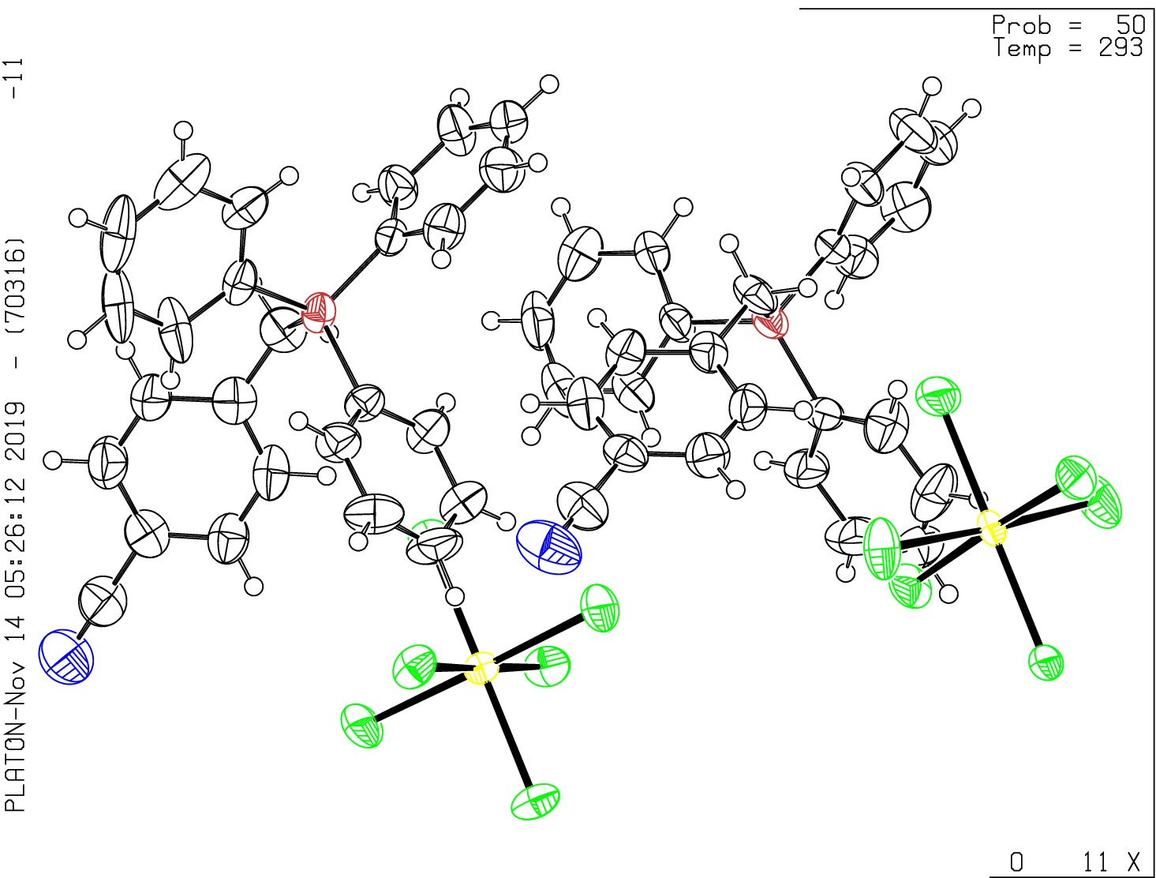Datablock 1238-0ma_b- ellipsoid plot

>- NOMOVE FORCED

z -20 1238-0ma_bC 1 2 1 R = 0.06 RES=

