checkCIF/PLATON report

Structure factors have been supplied for datablock(s) 1239_0ma_a

THIS REPORT IS FOR GUIDANCE ONLY. IF USED AS PART OF A REVIEW PROCEDURE FOR PUBLICATION, IT SHOULD NOT REPLACE THE EXPERTISE OF AN EXPERIENCED CRYSTALLOGRAPHIC REFEREE.

No syntax errors found. CIF dictionary Interpreting this report

Datablock: 1239_0ma_a

Bond precision: C-C = 0.0175 A Wavelength=0.71073

Cell: | a=19.876(16) | b=12.878(7) | c=21.395(10)
 | alpha=90 | beta=116.73(3) | gamma=90
Temperature: | 293 K

 | Calculated | Reported
Volume | 4891(5) | 4891(5)
Space group | P 21/c | P 1 21/c | 1
Hall group | -P 2ybc | -P 2ybc
Moiety formula 2(C25 H21 F P), Cl6 Hf Cl6 Hf, 2(C25 H21 F P)
Sum formula | C50 H42 Cl6 | F2 | Hf | P2 | C50 H42 Cl6 F2 Hf P2
Mr | 1133.97 |  |  |  | 1133.97
Dx,g cm-3 | 1.540 |  |  |  | 1.540
Z | 4 |  |  |  | 4
Mu (mm-1) | 2.567 |  |  |  | 2.567
F000 | 2256.0 |  |  |  | 2256.0
F000’ | 2258.70
h,k,lmax | 29,19,32 |  |  |  | 29,17,27
Nref | 17324 |  |  |  | 13346
Tmin,Tmax | 0.237,0.418 |  |  |  | 0.267,0.476
Tmin’ | 0.159

Correction method= # Reported T Limits: Tmin=0.267 Tmax=0.476
AbsCorr = MULTI-SCAN

Data completeness= 0.770 Theta(max)= 32.230
R(reflections)= 0.0738( 9744) wR2(reflections)= 0.1869( 13346) S = 1.159 Npar= 550

The following ALERTS were generated. Each ALERT has the format
test-name_ALERT_alert-type_alert-level.
Click on the hyperlinks for more details of the test.

Alert level A
PLAT029_ALERT_3_A _diffrn_measured_fraction_theta_full value Low . 0.770 Why?
PLAT330_ALERT_2_A | Large | Aver | Phenyl | C-C | Dist | C61 | -C66 |  | . | 1.44 | Ang.
PLAT331_ALERT_2_A | Small | Aver | Phenyl | C-C | Dist | C51 | -C56 |  | . | 1.34 | Ang.
Alert level B
PLAT330_ALERT_2_B | Large | Aver | Phenyl | C-C | Dist | C21 | -C26 |  | . | 1.42 | Ang.
PLAT910_ALERT_3_B Missing # of FCF Reflection(s) Below Theta(Min). 15 Note
PLAT934_ALERT_3_B Number of (Iobs-Icalc)/Sigma(W) > 10 Outliers .. 7 Check
PLAT971_ALERT_2_B | Check Calcd Resid. Dens. 2.08A |  |  |  |  |  | From | C23 |  | 3.23 | eA-3
PLAT971_ALERT_2_B | Check Calcd Resid. Dens. 1.57A |  |  |  |  |  | From | Cl1 |  | 2.59 | eA-3
Alert level C
ABSTY02_ALERT_1_C An _exptl_absorpt_correction_type has been given without a literature citation. This should be contained in the
_exptl_absorpt_process_details field. Absorption correction given as multi-scan
PLAT242_ALERT_2_C Low ’MainMol’ Ueq as Compared to Neighbors of C34 Check PLAT244_ALERT_4_C Low ’Solvent’ Ueq as Compared to Neighbors of Hf1 Check PLAT330_ALERT_2_C Large Aver Phenyl C-C Dist C41 -C46 . 1.42 Ang. PLAT331_ALERT_2_C Small Aver Phenyl C-C Dist C11 -C16 . 1.36 Ang. PLAT332_ALERT_2_C Large Phenyl C-C Range C41 -C46 . 0.16 Ang. PLAT342_ALERT_3_C Low Bond Precision on C-C Bonds ............... 0.01748 Ang. PLAT363_ALERT_2_C Long C(sp3)-C(sp2) Bond C71 - C77 . 1.63 Ang. PLAT906_ALERT_3_C Large K Value in the Analysis of Variance ...... 7.897 Check PLAT911_ALERT_3_C Missing FCF Refl Between Thmin & STh/L= 0.600 145 Report PLAT971_ALERT_2_C Check Calcd Resid. Dens. 1.36A From Hf1 1.99 eA-3
PLAT971_ALERT_2_C Check Calcd Resid. Dens. 1.00A From Cl5 1.72 eA-3
PLAT971_ALERT_2_C Check Calcd Resid. Dens. 1.21A From Hf1 1.69 eA-3
PLAT971_ALERT_2_C Check Calcd Resid. Dens. 1.26A From C77 1.60 eA-3
PLAT971_ALERT_2_C Check Calcd Resid. Dens. 1.18A From Hf1 1.54 eA-3
PLAT972_ALERT_2_C Check Calcd Resid. Dens. 1.09A From Cl1 -1.85 eA-3
PLAT972_ALERT_2_C Check Calcd Resid. Dens. 1.83A From C23 -1.76 eA-3
PLAT972_ALERT_2_C Check Calcd Resid. Dens. 1.53A From Cl1 -1.66 eA-3
PLAT972_ALERT_2_C Check Calcd Resid. Dens. 1.50A From Cl1 -1.55 eA-3
PLAT972_ALERT_2_C Check Calcd Resid. Dens. 0.77A From Hf1 -1.51 eA-3
PLAT977_ALERT_2_C Check Negative Difference Density on H5 -0.46 eA-3
PLAT977_ALERT_2_C Check Negative Difference Density on H44 -0.47 eA-3
PLAT977_ALERT_2_C Check Negative Difference Density on H73 -0.31 eA-3
PLAT977_ALERT_2_C Check Negative Difference Density on H77B -0.37 eA-3
PLAT978_ALERT_2_C Number C-C Bonds with Positive Residual Density. 0 Info

Alert level G
PLAT012_ALERT_1_G No _shelx_res_checksum Found in CIF ...... Please Check PLAT042_ALERT_1_G Calc. and Reported MoietyFormula Strings Differ Please Check PLAT063_ALERT_4_G Crystal Size Likely too Large for Beam Size .... 0.70 mm PLAT083_ALERT_2_G SHELXL Second Parameter in WGHT Unusually Large 75.67 Why ? PLAT199_ALERT_1_G Reported _cell_measurement_temperature ..... (K) 293 Check PLAT200_ALERT_1_G Reported _diffrn_ambient_temperature ..... (K) 293 Check PLAT333_ALERT_2_G Large Aver C6-Ring C-C Dist C71 -C76 . 1.43 Ang. PLAT432_ALERT_2_G Short Inter X...Y Contact Cl3 ..C66 3.15 Ang.
x,3/2-y,1/2+z = 4_576 Check PLAT793_ALERT_4_G Model has Chirality at P1 (Centro SPGR) R Verify PLAT793_ALERT_4_G Model has Chirality at P2 (Centro SPGR) S Verify PLAT794_ALERT_5_G Tentative Bond Valency for Hf1 (IV) . 3.32 Info PLAT912_ALERT_4_G Missing # of FCF Reflections Above STh/L= 0.600 3091 Note PLAT933_ALERT_2_G Number of OMIT Records in Embedded .res File ... 3 Note PLAT951_ALERT_5_G Calculated (ThMax) and CIF-Reported Kmax Differ 2 Units

PLAT952_ALERT_5_G Calculated (ThMax) and CIF-Reported Lmax Differ 5 Units PLAT957_ALERT_1_G Calculated (ThMax) and Actual (FCF) Kmax Differ 2 Units PLAT958_ALERT_1_G Calculated (ThMax) and Actual (FCF) Lmax Differ 5 Units PLAT992_ALERT_5_G Repd & Actual _reflns_number_gt Values Differ by 1 Check

3 ALERT level A = Most likely a serious problem - resolve or explain
5 ALERT level B = A potentially serious problem, consider carefully
25 ALERT level C = Check. Ensure it is not caused by an omission or oversight
18 ALERT level G = General information/check it is not something unexpected

7 ALERT type 1 CIF construction/syntax error, inconsistent or missing data
29 ALERT type 2 Indicator that the structure model may be wrong or deficient
6 ALERT type 3 Indicator that the structure quality may be low
5 ALERT type 4 Improvement, methodology, query or suggestion
4 ALERT type 5 Informative message, check

It is advisable to attempt to resolve as many as possible of the alerts in all categories. Often the minor alerts point to easily fixed oversights, errors and omissions in your CIF or refinement strategy, so attention to these fine details can be worthwhile. In order to resolve some of the more serious problems it may be necessary to carry out additional measurements or structure refinements. However, the purpose of your study may justify the reported deviations and the more
serious of these should normally be commented upon in the discussion or experimental section of a paper or in the "special_details" fields of the CIF. checkCIF was carefully designed to identify outliers and unusual parameters, but every test has its limitations and alerts that are not important
in a particular case may appear. Conversely, the absence of alerts does not guarantee there are no aspects of the results needing attention. It is up to the individual to critically assess their own results and, if necessary, seek expert advice.

Publication of your CIF in IUCr journals

A basic structural check has been run on your CIF. These basic checks will be run on all CIFs submitted for publication in IUCr journals (Acta Crystallographica, Journal of Applied Crystallography, Journal of Synchrotron Radiation); however, if you intend to submit to Acta Crystallographica Section C or E or IUCrData, you should make sure that full publication checks are run on the final version of your CIF prior to submission.

Publication of your CIF in other journals

Please refer to the Notes for Authors of the relevant journal for any special instructions relating to
CIF submission.

PLATON version of 07/08/2019; check.def file version of 30/07/2019

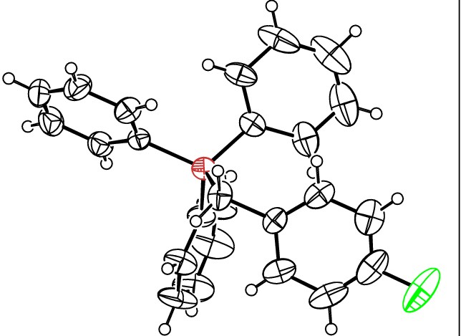Datablock 1239_0ma_a ·ellipsoid plot

>­
N
r--

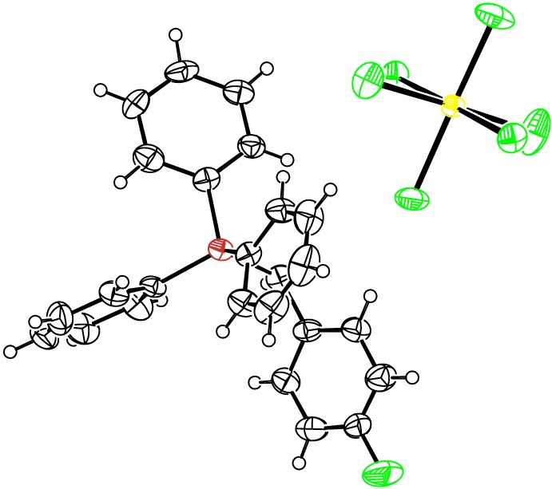CD
(Y")
0
r--

m
0
N

(Y")
'<.I."
N
'<I"
'<I"
0

(Y")
NOMOVE FORCED
Prob
Temp
50
293

>
0
.z
I
.z
0
f­
a:
_j
o_

z 60

1239 Oma aP 1 21/c 1

R 0.07

RES= 0 -57 X

