SUPPLEMENTARY MATERIALS – ДОПОЛНИТЕЛЬНЫЕ МАТЕРИАЛЫ

Синтез кальцийфосфатных порошков в неводных средах для сетереолитографической 3D-печати

Д. С. Ларионов, М. А. Кузина, П. В. Евдокимов, А. В. Гаршев, Н. К. Орлов, В.И. Путляев

Synthesis of calcium phosphate powders in non-aqueous media for stereolithography 3D-printing

D.S. Larionov, M.A. Kuzina, P.V. Evdokimov, A.V. Garshev, V.I. Putlayev

Russian Journal of Inorganic Chemistry Журнал неорганической химии Synthesis of sodium orthophosphate

Sodium orthophosphate was prepared in two different ways: solid-state reaction using sodium hydrogen phosphate Na2HPO4 and sodium carbonate Na2CO3 (all> 99%, Sigma-Aldrich) at a temperature of 900 ° C for 3 hours (1) and by crystallization from an aqueous solution of sodium hydroxide ( > 98%, Sigma-Aldrich) (2).

2Na2HPO4 + Na2CO3 → 2Na3PO4 + CO2↑ +H2O (1) Na2HPO4 + NaOH + 11H2O → Na3PO4·12H2O (2)
Synthesis of anhydrous phosphoric acid

The synthesis described here is an alternative to the methods described in the literature for the preparation of crystalline phosphoric acid [Brower G. Guide to inorganic synthesis // Mir. 1985. V.2.; Klyuchnikov N.G. Guide to inorganic synthesis // Chemistry.
1965.]. To obtain anhydrous solid phosphoric acid, concentrated H3PO4 phosphoric acid (85%, Sigma-Aldrich) was taken, to which the calculated amount of P2O5 phosphorus pentoxide (≥ 97%, Merck) was gradually added in small portions, while vigorously mixing the solution.
P2O5 + 3H2O → 2H3PO4 (3) According to the H3PO4 - H2O phase diagram, the required concentration of the acid
should be strictly above 95%, otherwise the solid phase crystallized from such a solution
would be H3PO4 · 0.5H2O hemihydrate [Kirk-Othmer Encyclopedia of Chemical Technology
// John Wiley & Sons, Inc. 3rd edition. V. 17, 1982. P. 433.]. The reaction mixture was cooled in an ice bath to avoid heating over 40 ° C (the temperature of the onset of polycondensation of the anion). The resulting phosphoric acid was gradually cooled to zero

degrees with stirring until crystallization began. After the crystallization process was completed, the acid was transferred to a desiccator and used for further syntheses.

Synthesis of calcium orthophosphate in ethylene glycol. Method 1

For the synthesis, 0.1 M solutions of CaCl2, Na3PO4, Na3PO4 · 12H2O salts (all
≥99%, Sigma-Aldrich) in ethylene glycol with a water content of up to 1000 ppm (measured by Fischer technique) were used. These solutions were heated to a temperature above 100 °C, then the solution of calcium chloride was added to the phosphate solutions at temperatures of
110 and 150 °C according to the following reactions:

3CaCl2 + 2Na3PO4 → Ca3(PO4)2↓ + 6NaCl (4)

3CaCl2 + 2Na3PO4·12H2O → Ca3(PO4)2↓+ 6NaCl + 12H2O (5)

Synthesis of calcium orthophosphate in ethylene glycol. Method 2

For the synthesis, the solution of phosphoric acid in ethylene glycol (up to 1000 ppm water according to Fischer technique) with a concentration of 0.1 M was prepared. The resulting solutions were heated and quickly added to each other at temperatures of 110, 130,
150 °C according to the reaction (6):
3(С2Н4(ОН)О)2Ca + 2H3PO4 → Ca3(PO4)2↓ + 6C2H4(OН)2 (6) The suspensions obtained via the first two methods were stirred for 10 minutes on a
magnetic stirrer, thereafter, the solutions were cooled, and the precipitates were separated from the solution by filtration or centrifugation.

The TG-DTA data for the TCP powder obtained at 110 ° C, after stirring for 2 hours, are presented in Fig. S1.

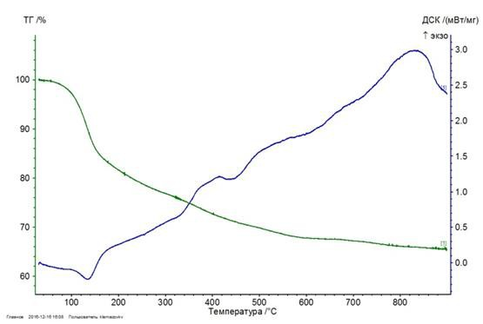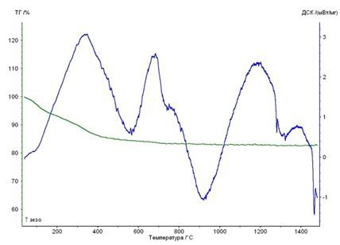
a b
Fig. S1. Thermal analysis of TCP a) precipitated at 110 ° C, while stirring for 2 hours, and drying at 90 ° C for 2 h, b) after washing with acetone the precipitate obtained at 110 ° C, while stirring for 2 hours
Рис. S1. Данные термического анализа ТКФ а) полученного при 110°С, после

перемешивания в течение 2 часов и сушки при 90°С в течение 2 ч, b) после промывки осадка, полученного при 110°С, после перемешивания в течение 2 часов, ацетоном

The evaporation of ethylene glycol begins below 100 ° C and continues up to a temperature of 500 ° C, thereafter, pyrolysis of ethylene glycol begins.

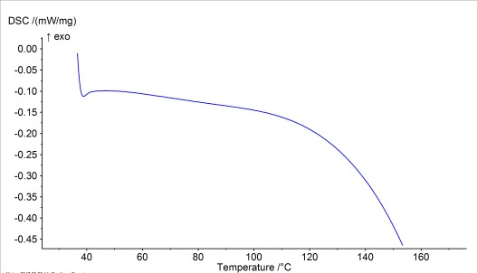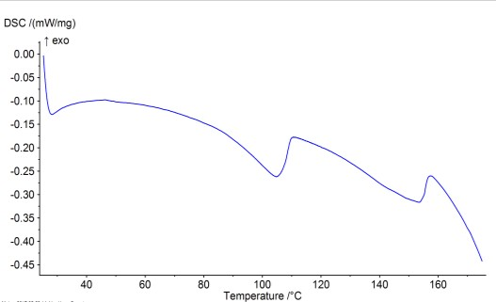а b

Fig. S2. a) DSC curve of the TCP sample after precipitation at 25 ° C and heating to 170 ° C. The peak at 110 ° C is responsible for the onset of crystallization of the powder. b) DSC curve of pure ethylene glycol, after heating to 160 ° C

Рис. S2. а) Данные ДСК образца ТКФ после осаждения при 25°С и нагревания до
170°С. Пик в районе 110°С отвечает за начало кристаллизации порошка. b) Данные
ДСК этиленгликоля, после нагревания до 160°С

In order to determine the temperature at which crystallization of a TCP sample obtained by dropping solutions at 25 ° C (X-ray amorphous precipitate) begins, a DSC analysis of the sample in ethylene glycol and pure ethylene glycol was performed and the thermal contribution of the removal of ethylene glycol (Fig. S2 b) was subtracted from the curve corresponding to the precipitate-ethylene glycol mixture (Fig. S2 a), taking into account mass loss and assuming constant rate of evaporation of ethylene glycol. Thus obtained DSC curve, associated with crystallization of the amorphous precipitate, is depicted in Fig. S3. The endothermic effect above 100 °C is clear visible. At this temperature and higher, crystalline β-TCP can be precipitated from ethylene glycol solution during the synthesis; therefore, this temperature can be considered as a border to start the growth and crystallization of X-ray amorphous particles.

EG (TCP+EG)
0,2 (TCP+EG) - EG

0,1

0,0

-0,1
DSC, mW/mg

-0,2

-0,3

-0,4

-0,5

-0,6

40 60 80 100 120 140 160 180
T, oC

Fig. S3. DSC curve of an X-ray amorphous TCP precipitate in EG after subtracting the thermal effects of solvent evaporation. The thermal effect above 100 ° C corresponds to crystallization of the amorphous particles

Рис. S3. Данные ДСК рентгеноаморфного осадка ТКФ в ЭГ после вычитания тепловых эффектов испарения растворителя. Тепловой эффект выше 100°С соответствует кристаллизации частиц

According to the data of IR spectroscopy (Fig. S4), the precipitates obtained at 110 and 130
°С have fewer OH-groups that can be related to water or ethylene glycol than the precipitates from the EG-water solution and the precipitate obtained at 90 °С. An unambiguous conclusion about the effect of water on the composition of the precipitate from these spectra is impossible, since there is a strong overlap of the spectra of ethylene glycol, HPO43- and water, as well as the spectra of ethylene glycol and PO43-. Noticeable peaks of stretching vibrations of OH-groups and water band in the region of 3000 cm-1 were not detected. However, the main bands of PO43- groups can be determined unambiguously. For samples TCP110 and TCP130, these spectra correspond to β-TCP, and for TCP90, TCPaq, and TCPaq1, they correspond to amorphous TCP or non-stoichiometric HA.

ν (H O)
as 2
v (COH) v2(CH2)

v (CO)+ v (PO )
1 3 4

v (CH )
3

ν (H O) 5 2
s 2

v (PO )
4 4

TCP90
TCP110
TCP130
TCPaq
TCPaq1

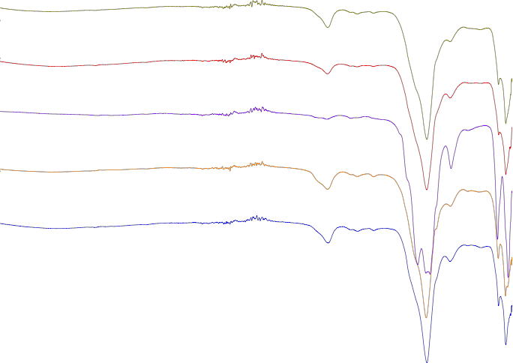3500 3000 2500 2000 1500 1000

v, cm-1

Fig. S4. IR spectra of the TCP powders. TCP90, TCP110, TCP130 – the precipitates after draining the solutions in the EG at 90, 110, 130 °С, respectively, and subsequent stirring for
2 hours. TCPaq and TCPaq1 – the precipitates obtained in the EG:water solution =10: 1 and
6: 1, respectively

Рис. S4. Данные ИК спектроскопии для порошков ТКФ. TCP90, TCP110, TCP130 – осадок после сливания растворов в ЭГ при 90, 110, 130°С соответственно и перемешивания в течение 2 ч. TCPaq и TCPaq1 – осадки, полученные в растворе ЭГ- вода 10 : 1 и 6 : 1 соответственно

Syntheses of Calcium Pyrophosphate Powders Ca2P2O7 (CPP), CPP/TCP Composites and
Substituted Calcium Orthophosphates

а) Synthesis of CPP

The philosophy of the synthesis no.5 (from the main text of the article) was used unchanged for the following reasons: a) greater yield, b) the ability to use the same synthesis scheme to fabricate CPP/TCP composites. Since the samples of commercial ammonium pyrophosphate, both domestic and imported, are contaminated with polyphosphates (due to usage of heat-treated phosphoric acid), we used the previously developed synthesis method using ion-exchange resins to obtain ammonium pyrophosphate [T. V. Safronova, V. I. Putlyaev, S. A. Kurbatova, T. B. Shatalova, D. S. Larionov, D. A. Kozlov, and P. V. Evdokimov. Properties of amorphous calcium pyrophosphate powder synthesized via ion

exchange for the preparation of bioceramics. Inorganic Materials. 2015. V. 51. No. 11. P.1177-1184].

Precipitation of CPP in EG. The ammonium pyrophosphate, obtained as described above (solution 0.05M), and calcium ethylene glycolate (solution 0.15M) were quickly drained at temperatures in the range of 90-130 ° С according to the reaction (7):
2(С2Н4(ОН)О)2Ca + (NH4)4P2O7 → Ca2P2O7↓ + 4 C2H4(OН)2 + 4NH3↑ (7) It should be noted that above 90 °C, fully substituted ammonium pyrophosphate begins to
lose ammonia and turns into di- and trihydrogen pyrophosphates (NH4)2H2P2O7 and
NH4H3P2O7, which are soluble better than the completely substituted salt. According to SEM (Fig. S5 a), the precipitated CPP is characterized by a broad distribution of particle size, a tendency to strong agglomeration with the formation of faceted particles is noticeable; according to XRD data, the precipitate is X-ray amorphous regardless of the synthesis temperature, deposition rate, and type of pyrophosphate reagent (Fig. S5 b). With the slow addition of ammonium dihydrogen phosphate, the sizes of the particles are uniform; however, the precipitate is X-ray amorphous even after 1 h of aging at 130 °C. It should be noted that due to the amorphous nature of the precipitate, stoichiometry of the final product might be violated. We noted that a temperature of 110 °C is optimal for precipitation, traces of water begin to exert a lesser effect (there may be an admixture of HA), while larger dihydrogen pyrophosphate condensates into polyphosphate, which prevents the precipitation of polyphosphate. In both cases, in the product after firing, there may be an admixture of TCP.

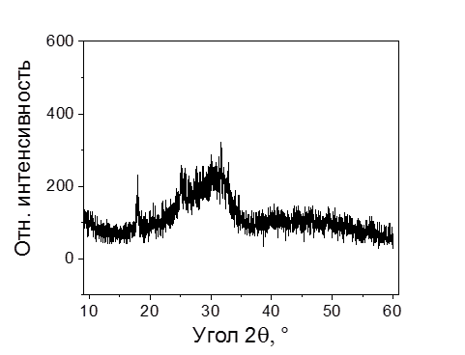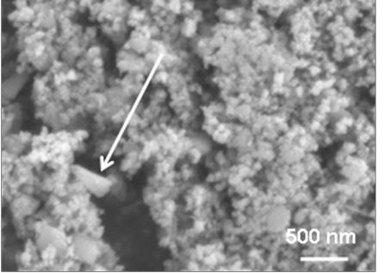

а b
Fig. S5. a) Micromorphology of the CPP-precipitate after steering in the EG solution for 5 hours at 110 °С (the arrow marks large faceted particle resulting from agglomeration of primary spherical particles), b) XRD data for the products of slow precipitation of calcium pyrophosphate from EG at 130 ° C followed by aging for 1 hr

Рис. S5. а) Микроморфология осадка ПФК после выдерживания в растворе ЭГ в течение 5 часов, 110 °С (присутствуют крупные ограненные частицы, возникшие в результате агломерации первичных сферических частиц - стрелка), b) данные РФА для продуктов медленного осаждения пирофосфата кальция из ЭГ при 130 °С с последующим выдерживанием в течение 1 ч.

b) Synthesis of TCP/CPP composites

The synthesis was carried out from a mixed-anionic solution in the EG according to the scheme:

(3-у)C2H4O2Ca + (2-2у)NH4H2PO4 + у(NH4)4P2O7 → Ca3-y(P2O7)y(PO4)2-2y ↓ +
+(3-у) C2H4(OН)2 + (2+2у)NH3↑ (8)

The mixed anionic precursor Ca3-y(P2O7)y(PO4)2-2y (≡TCP/CPP) was precipitated at temperatures of 90-130 ° С in order to avoid its separation to the individual phosphates and loss of homogeneity; after precipitation, the precipitate was always X-ray amorphous. For y
= 1/2 after firing at 900 ° C for 5 hours, the sample was, according to the quantitative XRD (corundum number technique), a mixture of β-TCP: β-CPP = 1: 1. In scheme (8), both fully substituted and ammonium dihydrogen pyrophosphate were used. It should be noted that crystallization of an amorphous precipitate gives a different phase sequence for TCP and CPP in comparison with an amorphous precipitate from aqueous solutions: in the case of EG, TCP crystallizes first as β-TCP, and with CPP as α-CPP; and vice versa in the case of water. The reason for this is not yet fully understood. However, it is obvious that crystallization of the initially amorphous precipitate of CPP or CPP /TCP in the case of synthesis in EG requires considerable time and elevated temperature. Thus, the synthesis of crystalline powders CPP and CPP / TCP by this method is quite difficult. In the case of calcium polyphosphates (polyCP) and CPP/polyCP composites, even a noticeable quantitative precipitation was not achieved, which to some extent reproduces the situation of synthesis from aqueous solutions.

c) Synthesis of substituted orthophosphates

The features of the synthesis no.5 from the main text of the article, namely: a) compliance with the stoichiometry of the initial solutions in the stoichiometry of the precipitate, b) the poor solubility of weakly protonated (maximally substituted) phosphates in the EG, allowed us to test the synthesis of more soluble than TCP (and more than HA) phosphates, which is absolutely impossible in water solutuions. In particular, with a large excess (2-3 times) of sodium-containing reagent, it is possible to obtain double calcium- sodium phosphate, the so-called sodium rhenanite - CaNaPO4:

C2H4O2Ca + HCOONa + NH4H2PO4 → CaNaPO4↓ + C2H4(OH)2 + HCOONH4, (9)

in the form of an amorphous precipitate, which then crystallizes in β-CaNaPO4 upon heating. The compositions of the Ca3(PO4)2-CaNaPO4 system are promising resorbable materials that are currently manufactured only using high-temperature solid-phase synthesis [P. V. Evdokimov, V. I. Putlyaev, V. K. Ivanov, A. V. Garshev, T. B. Shatalova, N. K. Orlov, E. S. Klimashina, and T. V. Safronova. Phase equilibria in the tricalcium phosphate–mixed calcium sodium (potassium) phosphate systems. Russian Journal of Inorganic Chemistry.
2014.V. 59. No. 11. S.1219-1427]. However, when trying to synthesize such a material with an arbitrary composition:

(3-х)C2H4O2Ca +2хHCOONa +2NH4H2PO4 → Ca(3-х)Na2х(PO4)2↓ + (3-х)C2H4(OH)2 +
+2хHCOONH4. + (2-2х) NH3, (10)

it is not possible to reproduce the stoichiometry of the solution in the corresponding precipitate, which may be due to a) a better solubility in sodium hydrogenphosphate compared with fully substituted sodium orthophosphate [Kurzin A.V., Evdokimov A.N., Golikova V.S., and Fedorov V.A. Solubility of potassium and sodium orthophosphates in ethylene glycol // Russian Journal of Applied Chemistry. 2012. V. 85. No. 5. P. 841–842], b) too large difference in the solubility of calcium and sodium orthophosphates in the EG. Nevertheless, we believe that this synthesis can be elaborated well, in principle, to obtain powders of substituted calcium orthophosphates.

Table S1. Results of TCP synthesis in various non-aqueous media

Таблица S1. Результаты синтеза ТКФ в различных неводных средах

Solvent | Са-reagent | РО4-reagent | Conditions of synthesis | Target phases (products) | Yield, % | Difficulties
Ethanol | CaY2 (Y=Cl, NO3)  CaO(CaCO3) Ca(CH3COO)2 | X2HPO4 (+XOH,  X=Na, NH4) Ca(H2PO4)2  H3PO4 (anhydr.) | draining, up to 90ºС  idem idem | СаНРО4 1-2 μm, ACP (HA, TCP)* 100 -  200 nm  CaHPO4 , 1-2 μm  CaHPO4, 1-2 μm | <<50  idem idem | Very low solubility of the  phosphate reagent, low yield, impurities of acid phosphates
Butandiol-1,4 | CaCl2 | X2HPO4 (+XOH,  X=Na, NH4) | draining, 90-190ºС | СаНРО4 1-2 μm, ACP  100 -200 nm (HА, ТCP) | idem | idem
Hexandiol-1,6 | CaCl2 | X2HPO4 (+XOH,  X=Na, NH4) | draining, 90-200ºС | СаНРО4 1-2 μm, ACP  100 -200 nm (HA, ТCP) | idem | idem
Glycerol | CaCl2  CaO(CaCO3) | X2HPO4 (+XOH,  X=Na, NH4) Ca(H2PO4)2 | draining, 120-190ºС  idem | СаНРО4 1-2 μm, ACP (HА, ТCP)<100 -200 nm  ACP(HА) <100 nm | idem  <20 | idem, the difficulty of  isolating the product from a viscous solution
Oleic acid/ tributil phosphate  (ТBP) /trioctylphosphine oxide  (ТОРО) | Са-олеат | Н3РО4·ТБФ(ТОРО) | draining, 100-180ºС | ACP(HА, ТCP) <100 nm | <50 | idem, the difficulty of  isolating the product from a viscous solution
Ethylene glycol

Method 1  Method 2  Method 3 | CaCl2  (С2Н4(ОН)О)2Ca  (С2Н4(ОН)О)2Ca | Na3PO4,  Na3PO4·12H2O H3PO4 (anhydr.)  NH4H2PO4  ((NH4)2PO4) | draining, 110-150ºС  draining, 110-150ºС  dropwise addition,  110-150ºС | ACP (ТCP, HА)<100 nm ACP (ТCP) )<100 nm TCP, 90-600 nm | <100  100  100 | Difficulties in the complete removal of ethylene glycol (pyrolysis is required)
Ionic liquids (IL) [emim]Br  [emim][NTf2] | CaCl2  idem | X2HPO4 (+XOH, X=Na, NH4)  idem | heating, 80-250ºС  heating, до 300ºС | ACP(HА, ТCP) <100 nm,  Са2Р2О7,  Са(РО3)2, CaNaPO4 | <<50 | Difficulties in isolating a product from IL, cleaning IL from impurities
Melt of KNO3/NaNO3 | Ca(NO3)2 | Na2HPO4(+NaOH) | heating, до 275ºС | ACP(HА,CaNaPO4) 100-  500 nm, Na4P2O7 | <<50 | Difficulties in isolating  product from solidified melt
* A product of the ACP (phase 1, phase 2) type means an amorphous precipitation product, which at 900 ° C crystallizes in phase 1 and phase 2 for 1 h r.

