Supplement

Thermodynamic and magnetic properties of praseodymium stannate

А.V. Tyurin, A.V. Khoroshilov, M.A. Ryumin, V.N. Guskov, P.G. Gagarin, G.E. Nikiforova, O.N. Kondrat'eva, K.I. Pechkovskaya, N.N. Efimov, V.М. Gurevich. K.S. Gavrichev

Журнал неорганической химии. 2020

Russian Journal of Inorganic Chemistry, 2020

Table S1. Experimental heat capacity of Pr2Sn2O7, in J/(mol K).

T, K | Cp | T, K | Cp | T, K | Cp | T, K | Cp
Series 1 |  | 207.18 | 189.9 | 90.21 | 86.49 | 33.71 | 21.79
103.82 | 102.0 | 211.73 | 192.6 | 92.59 | 89.27 | 35.52 | 23.52
107.58 | 106.1 | 216.28 | 195.3 | 95.13 | 92.20 | 37.32 | 25.24
111.31 | 110.1 | 220.95 | 197.7 | 97.75 | 95.19 | 40.66 | 28.44
115.04 | 114.0 | 225.43 | 200.0 | Series 5 |  | 42.95 | 30.68
118.76 | 117.8 | 230.14 | 202.4 | 7.90 | 0.6589 | 44.75 | 32.49
122.49 | 121.6 | 234.64 | 204.8 | 8.64 | 0.9145 | 46.52 | 34.32
126.21 | 125.3 | 239.22 | 207.1 | 9.31 | 1.112 | 48.30 | 36.19
130.17 | 129.2 | 243.80 | 209.5 | 9.70 | 1.286 | 50.06 | 38.10
133.89 | 132.8 | 248.25 | 211.8 | 10.67 | 1.857 | 51.83 | 40.05
137.62 | 136.3 | 252.68 | 213.8 | 11.48 | 2.223 | 53.60 | 42.05
141.37 | 139.8 | 257.06 | 215.7 | 12.73 | 2.959 | 55.36 | 44.08
145.11 | 143.2 | 261.42 | 217.6 | 13.27 | 3.515 | 57.11 | 46.13
148.93 | 146.6 | 265.75 | 219.4 | 14.37 | 4.015 | 58.86 | 48.21
Series 2 |  | 270.05 | 221.1 | 15.74 | 5.133 | 60.60 | 50.31
143.75 | 141.9 | 274.32 | 222.7 | 16.69 | 6.012 | 62.35 | 52.44
148.47 | 146.2 | 278.57 | 224.3 | 17.26 | 6.548 | 64.11 | 54.59
152.13 | 149.4 | 282.76 | 225.9 | 18.63 | 7.688 | 65.86 | 56.76
Series 3 |  | 286.93 | 227.4 | 19.88 | 8.775 | 67.62 | 58.94
164.39 | 159.6 | 291.04 | 228.8 | 20.79 | 9.659 | 69.46 | 61.22
169.13 | 163.4 | 295.12 | 230.1 | 22.63 | 11.02 | 71.22 | 63.41
172.79 | 166.2 | 299.05 | 231.4 | 24.80 | 12.79 | 73.18 | 65.84
176.43 | 169.0 | 303.63 | 232.9 | 26.86 | 14.67 | 75.38 | 68.57
180.08 | 171.7 | 310.04 | 234.8 | Series 6 |  | 77.60 | 71.31
183.72 | 174.3 | 317.49 | 237.0 | 22.62 | 12.62 | 79.83 | 74.05
187.36 | 176.9 | 324.89 | 239.0 | 24.41 | 13.10 | 82.08 | 76.78
191.01 | 179.4 | 332.20 | 241.0 | 26.33 | 14.50 | 84.34 | 79.52
194.68 | 181.9 | 339.45 | 242.8 | 28.22 | 16.30 | 86.62 | 82.25
198.40 | 184.3 | 346.58 | 244.5 | 30.06 | 18.20
202.49 | 187.0 | Series 4 |  | 31.89 | 20.02

Table S2. Coefficients of equation (1) for Pr2Sn2O7 heat capacity

j | Aj  J/(mol K)
0 | -0.179101
1 | 0.239855103
2 | 0.1766969105
3 | -0.137358618106
4 | 0.513804873106
5 | -0.111208153107
6 | 0.141633566107
7 | -0.98483615106
8 | 0.28839652106

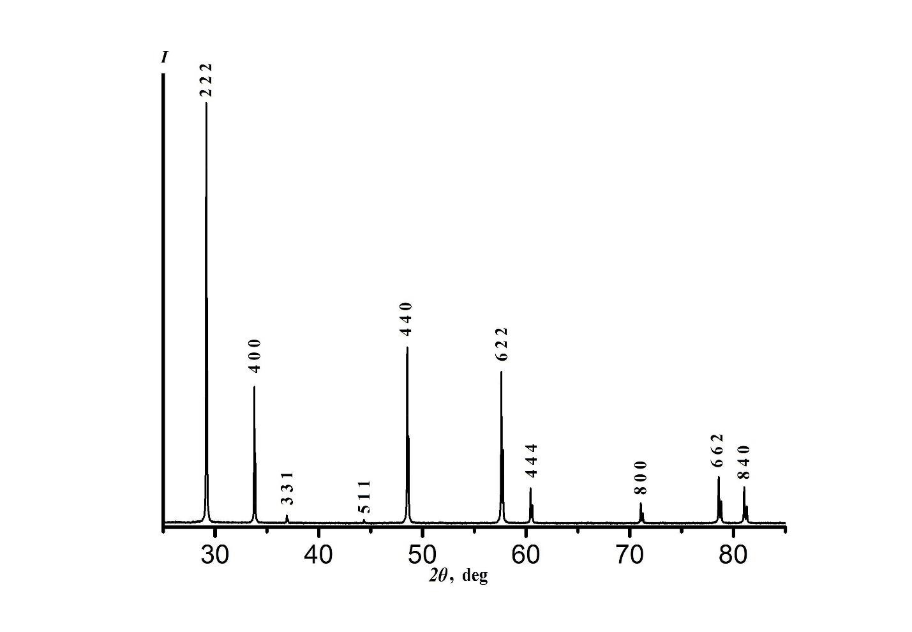

Fig.S1. X-ray pattern of Pr2Sn2O7 specimen.

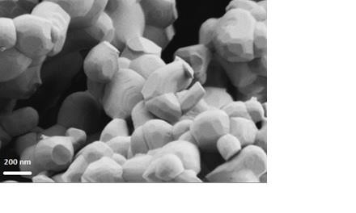

Fig.S2. SEM image of Pr2Sn2O7 ceramics.

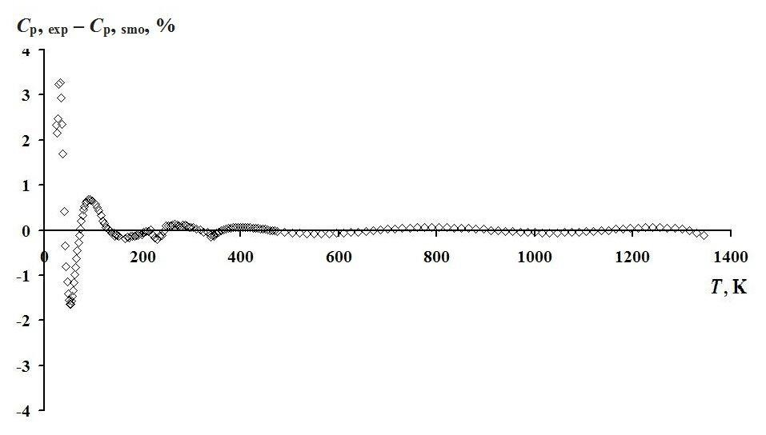

Fig.S3. Deviation of experimental heat capacities of Pr2Sn2O7 from smoothed values.

