checkCIF/PLATON report

You have not supplied any structure factors. As a result the full set of tests cannot be run.

THIS REPORT IS FOR GUIDANCE ONLY. IF USED AS PART OF A REVIEW PROCEDURE FOR PUBLICATION, IT SHOULD NOT REPLACE THE EXPERTISE OF AN EXPERIENCED CRYSTALLOGRAPHIC REFEREE.

No syntax errors found. CIF dictionary Interpreting this report

Datablock: seyf120

Bond precision: C-C = 0.0195 A Wavelength=0.71073

Cell: | a=14.5962(10) | b=14.6740(9) | c=15.3992(10)
 | alpha=73.821(6) | beta=76.019(6) | gamma=82.003(6)
Temperature: | 294 K

Calculated Reported Volume 3064.7(4) 3064.7(4) Space group P -1 P -1
Hall group -P 1 -P 1
Moiety formula C20 H20 Ge4 O32, 4(C24 H16 C20 H20 Ge4 O32, 4(C24 H16

Cl Cu N4), 8(H2 O)
Sum formula C116 H100 Cl4 Cu4 Ge4 N16
O40
Cl Cu N4), 8(H2 O)
C116 H100 Cl4 Cu4 Ge4 N16
O40

Mr 3044.56 3044.43
Dx,g cm-3 1.650 1.650
Z 1 1
Mu (mm-1) 1.826 1.826
F000 1540.0 1540.0
F000’ 1543.10
h,k,lmax 17,18,18 17,18,18
Nref 12033 12002
Tmin,Tmax | 0.420,0.578 | 0.480,1.000
Tmin’ | 0.331

Correction method= # Reported T Limits: Tmin=0.480 Tmax=1.000
AbsCorr = MULTI-SCAN

Data completeness= 0.997 Theta(max)= 25.999

R(reflections)= 0.0986( 4973) wR2(reflections)= 0.2693( 12002) S = 0.986 Npar= 831

The following ALERTS were generated. Each ALERT has the format
test-name_ALERT_alert-type_alert-level.
Click on the hyperlinks for more details of the test.

Alert level B
PLAT341_ALERT_3_B Low Bond Precision on C-C Bonds ............... 0.0195 Ang. PLAT417_ALERT_2_B Short Inter D-H..H-D H19A ..H20A . 1.85 Ang.
2-x,-y,2-z = 2_757 Check PLAT420_ALERT_2_B D-H Without Acceptor O1 --H1 . Please Check PLAT420_ALERT_2_B D-H Without Acceptor O20 --H20A . Please Check PLAT420_ALERT_2_B D-H Without Acceptor O20 --H20B . Please Check

Alert level C
RINTA01_ALERT_3_C The value of Rint is greater than 0.12
Rint given 0.126
PLAT020_ALERT_3_C The Value of Rint is Greater Than 0.12 ......... 0.126 Report PLAT026_ALERT_3_C Ratio Observed / Unique Reflections (too) Low .. 41% Check PLAT084_ALERT_3_C High wR2 Value (i.e. > 0.25) ................... 0.27 Report PLAT220_ALERT_2_C NonSolvent Resd 1 O Ueq(max) / Ueq(min) Range 3.7 Ratio PLAT230_ALERT_2_C Hirshfeld Test Diff for Ge1 --O4 . 5.2 s.u. PLAT234_ALERT_4_C Large Hirshfeld Difference O2 --C1 . 0.17 Ang. PLAT234_ALERT_4_C Large Hirshfeld Difference O7 --C5 . 0.17 Ang. PLAT234_ALERT_4_C Large Hirshfeld Difference O10 --C6 . 0.18 Ang. PLAT234_ALERT_4_C Large Hirshfeld Difference O11 --C7 . 0.22 Ang. PLAT234_ALERT_4_C Large Hirshfeld Difference O12 --C8 . 0.18 Ang. PLAT234_ALERT_4_C Large Hirshfeld Difference C3 --C4 . 0.19 Ang. PLAT234_ALERT_4_C Large Hirshfeld Difference C9 --C10 . 0.19 Ang. PLAT234_ALERT_4_C Large Hirshfeld Difference N3 --C27 . 0.17 Ang. PLAT234_ALERT_4_C Large Hirshfeld Difference C0AA --C17 . 0.19 Ang. PLAT234_ALERT_4_C Large Hirshfeld Difference C18 --C20 . 0.19 Ang. PLAT234_ALERT_4_C Large Hirshfeld Difference C26 --C28 . 0.20 Ang. PLAT234_ALERT_4_C Large Hirshfeld Difference C28 --C29 . 0.25 Ang. PLAT234_ALERT_4_C Large Hirshfeld Difference C30 --C31 . 0.25 Ang. PLAT234_ALERT_4_C Large Hirshfeld Difference C30 --C32 . 0.24 Ang. PLAT234_ALERT_4_C Large Hirshfeld Difference N7 --C51 . 0.20 Ang. PLAT234_ALERT_4_C Large Hirshfeld Difference C50 --C52 . 0.17 Ang. PLAT234_ALERT_4_C Large Hirshfeld Difference C53 --C54 . 0.19 Ang. PLAT241_ALERT_2_C High ’MainMol’ Ueq as Compared to Neighbors of C21 Check PLAT241_ALERT_2_C High ’MainMol’ Ueq as Compared to Neighbors of C53 Check PLAT241_ALERT_2_C High ’MainMol’ Ueq as Compared to Neighbors of C56 Check PLAT242_ALERT_2_C Low ’MainMol’ Ueq as Compared to Neighbors of C1 Check PLAT242_ALERT_2_C Low ’MainMol’ Ueq as Compared to Neighbors of C9 Check PLAT242_ALERT_2_C Low ’MainMol’ Ueq as Compared to Neighbors of C50 Check PLAT250_ALERT_2_C Large U3/U1 Ratio for Average U(i,j) Tensor .... 2.2 Note PLAT260_ALERT_2_C Large Average Ueq of Residue Including O18 0.104 Check PLAT260_ALERT_2_C Large Average Ueq of Residue Including O19 0.256 Check PLAT260_ALERT_2_C Large Average Ueq of Residue Including O20 0.192 Check PLAT414_ALERT_2_C Short Intra D-H..H-X H5 ..H9 1.92 Ang.
x,y,z = 1_555 Check
PLAT417_ALERT_2_C Short Inter D-H..H-D H16 ..H17A . 2.14 Ang. x,y,z = 1_555 Check
PLAT601_ALERT_2_C Structure Contains Solvent Accessible VOIDS of . 74 Ang**3

Alert level G
PLAT002_ALERT_2_G Number of Distance or Angle Restraints on AtSite 10 Note PLAT003_ALERT_2_G Number of Uiso or Uij Restrained non-H Atoms ... 7 Report PLAT005_ALERT_5_G No Embedded Refinement Details Found in the CIF Please Do ! PLAT007_ALERT_5_G Number of Unrefined Donor-H Atoms .............. 12 Report

PLAT154_ALERT_1_G The s.u.’s on the Cell Angles are Equal ..(Note) 0.006 Degree PLAT335_ALERT_2_G Check Large C6 Ring C-C Range C26 -C28 0.17 Ang. PLAT432_ALERT_2_G Short Inter X...Y Contact Cl2 ..C20 3.23 Ang.
x,1+y,-1+z = 1_564 Check PLAT720_ALERT_4_G Number of Unusual/Non-Standard Labels .......... 2 Note PLAT790_ALERT_4_G Centre of Gravity not Within Unit Cell: Resd. # 2 Note
C24 H16 Cl Cu N4
PLAT790_ALERT_4_G Centre of Gravity not Within Unit Cell: Resd. # 4 Note
H2 O
PLAT790_ALERT_4_G Centre of Gravity not Within Unit Cell: Resd. # 5 Note
H2 O
PLAT790_ALERT_4_G Centre of Gravity not Within Unit Cell: Resd. # 6 Note
H2 O
PLAT793_ALERT_4_G Model has Chirality at C2 (Centro SPGR) R Verify PLAT793_ALERT_4_G Model has Chirality at C3 (Centro SPGR) R Verify PLAT793_ALERT_4_G Model has Chirality at C4 (Centro SPGR) S Verify PLAT793_ALERT_4_G Model has Chirality at C7 (Centro SPGR) R Verify PLAT793_ALERT_4_G Model has Chirality at C8 (Centro SPGR) R Verify PLAT793_ALERT_4_G Model has Chirality at C9 (Centro SPGR) S Verify PLAT794_ALERT_5_G Tentative Bond Valency for Cu1 (II) . 2.24 Info PLAT794_ALERT_5_G Tentative Bond Valency for Cu2 (II) . 2.23 Info PLAT860_ALERT_3_G Number of Least-Squares Restraints ............. 50 Note

0 ALERT level A = Most likely a serious problem - resolve or explain
5 ALERT level B = A potentially serious problem, consider carefully
36 ALERT level C = Check. Ensure it is not caused by an omission or oversight
21 ALERT level G = General information/check it is not something unexpected

1 ALERT type 1 CIF construction/syntax error, inconsistent or missing data
23 ALERT type 2 Indicator that the structure model may be wrong or deficient
6 ALERT type 3 Indicator that the structure quality may be low
28 ALERT type 4 Improvement, methodology, query or suggestion
4 ALERT type 5 Informative message, check

It is advisable to attempt to resolve as many as possible of the alerts in all categories. Often the minor alerts point to easily fixed oversights, errors and omissions in your CIF or refinement strategy, so attention to these fine details can be worthwhile. In order to resolve some of the more serious problems it may be necessary to carry out additional measurements or structure refinements. However, the purpose of your study may justify the reported deviations and the more
serious of these should normally be commented upon in the discussion or experimental section of a paper or in the "special_details" fields of the CIF. checkCIF was carefully designed to identify outliers and unusual parameters, but every test has its limitations and alerts that are not important
in a particular case may appear. Conversely, the absence of alerts does not guarantee there are no aspects of the results needing attention. It is up to the individual to critically assess their own results and, if necessary, seek expert advice.

Publication of your CIF in IUCr journals

A basic structural check has been run on your CIF. These basic checks will be run on all CIFs submitted for publication in IUCr journals (Acta Crystallographica, Journal of Applied Crystallography, Journal of Synchrotron Radiation); however, if you intend to submit to Acta Crystallographica Section C or E or IUCrData, you should make sure that full publication checks are run on the final version of your CIF prior to submission.

Publication of your CIF in other journals

Please refer to the Notes for Authors of the relevant journal for any special instructions relating to
CIF submission.

PLATON version of 22/04/2020; check.def file version of 09/03/2020

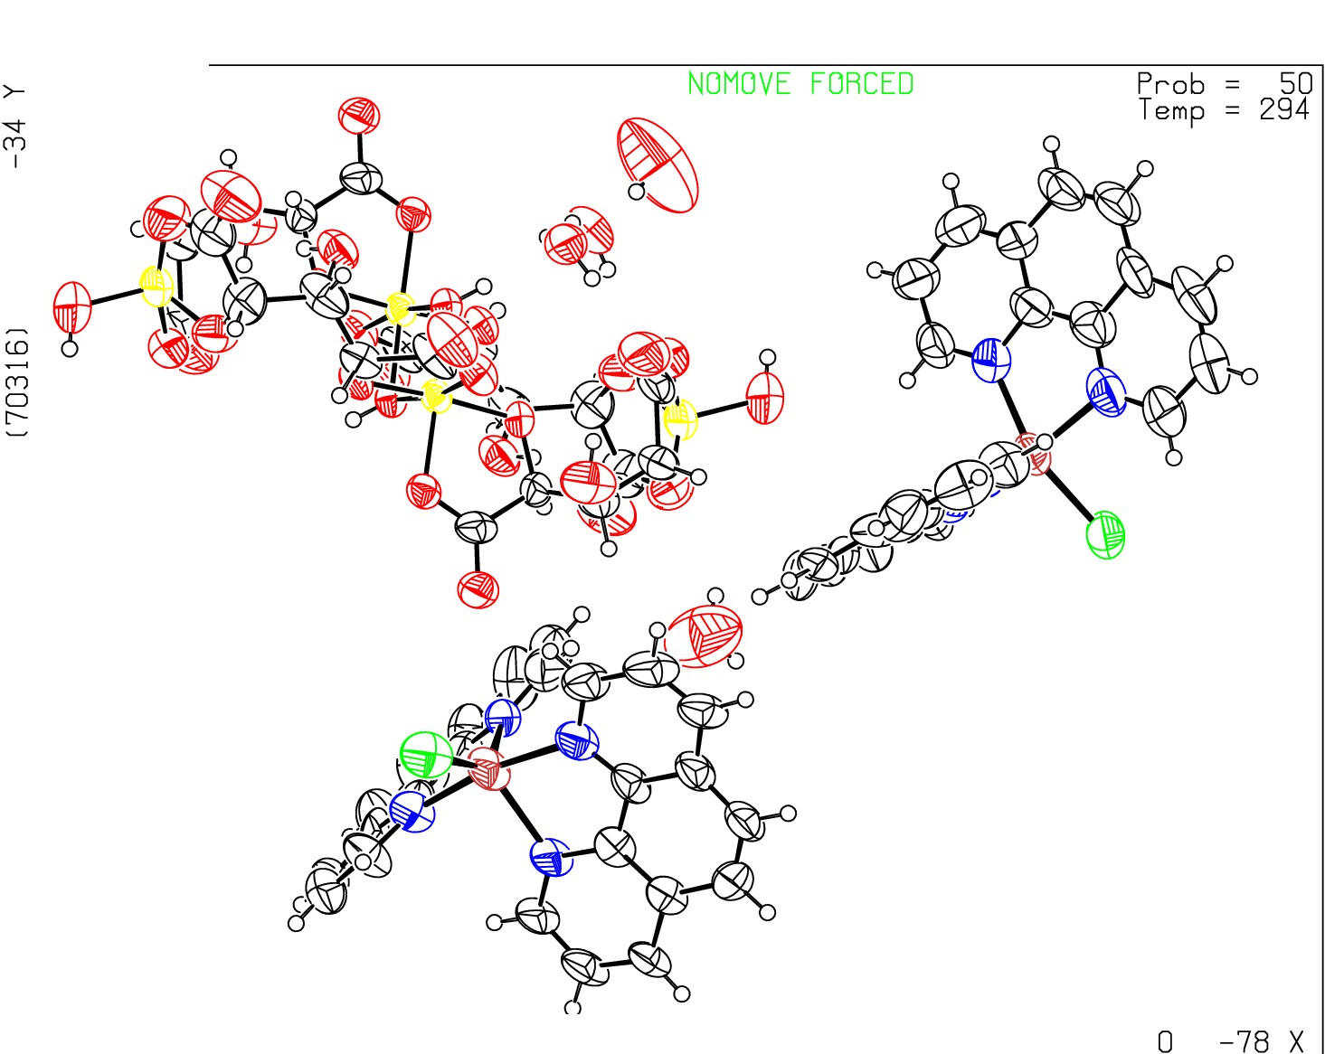Datablock seyfl20 - ellipsoid plot

0
N
0
N
m
0
m
N

t'­ N
L
Q_
CI
I
:z:
0
f­
CI
_j
o_

z -143 se f120 p -1 R = 0. 10 RES=

