checkCIF/PLATON report

You have not supplied any structure factors. As a result the full set of tests cannot be run.

THIS REPORT IS FOR GUIDANCE ONLY. IF USED AS PART OF A REVIEW PROCEDURE FOR PUBLICATION, IT SHOULD NOT REPLACE THE EXPERTISE OF AN EXPERIENCED CRYSTALLOGRAPHIC REFEREE.

No syntax errors found. CIF dictionary Interpreting this report

Datablock: s155_sq

Bond precision: C-C = 0.0095 A Wavelength=0.71073

Cell: | a=11.4654(5) | b=12.0318(5) | c=16.5011(6)
 | alpha=107.797(3) | beta=94.373(3) | gamma=96.281(3)
Temperature: | 293 K

Moiety formula

Cu N4 O), 8(H2 O) [+
solvent]
O32, 2(C24 H18
Cu N4 O), 8(H2 O)
 | Calculated |  |  | Reported
Volume | 2139.86(16) |  |  | 2139.86(16)
Space group | P -1 |  |  | P -1
Hall group | -P 1 |  |  | -P 1
 | C20 H20 Ge4 | O32, | 2(C24 H | 18 C20 H20 Ge4

C68 H72 Cu2 Ge4 N8 O42 [+
Sum formula
solvent] C68 H72 Cu2 Ge4 N8 O42
Mr 2090.88 2090.77
Dx,g cm-3 1.622 1.622
Z 1 1
Mu (mm-1) 1.973 1.973
F000 1058.0 1058.0
F000’ 1059.78
h,k,lmax 14,15,21 14,15,21
Nref 9824 9808
Tmin,Tmax 0.403,0.553 0.377,1.000
Tmin’ 0.359

Correction method= # Reported T Limits: Tmin=0.377 Tmax=1.000
AbsCorr = MULTI-SCAN

Data completeness= 0.998 Theta(max)= 27.499

R(reflections)= 0.0594( 6514) wR2(reflections)= 0.1343( 9808) S = 0.993 Npar= 568

The following ALERTS were generated. Each ALERT has the format
test-name_ALERT_alert-type_alert-level.
Click on the hyperlinks for more details of the test.

Alert level B
PLAT417_ALERT_2_B Short Inter D-H..H-D H1 ..H20B . 2.05 Ang. x,y,z = 1_555 Check
PLAT417_ALERT_2_B Short Inter D-H..H-D H16A ..H21B . 1.80 Ang.
-x,-y,1-z = 2_556 Check PLAT420_ALERT_2_B D-H Without Acceptor O18 --H18A . Please Check PLAT420_ALERT_2_B D-H Without Acceptor O20 --H20A . Please Check PLAT990_ALERT_1_B Deprecated .res/.hkl Input Style SQUEEZE Job ... ! Note

Alert level C
PLAT193_ALERT_1_C Cell and Diffraction Temperatures Differ by .... 1 Degree PLAT230_ALERT_2_C Hirshfeld Test Diff for N4 --C34 . 6.9 s.u. PLAT241_ALERT_2_C High ’MainMol’ Ueq as Compared to Neighbors of C34 Check PLAT250_ALERT_2_C Large U3/U1 Ratio for Average U(i,j) Tensor .... 3.6 Note PLAT260_ALERT_2_C Large Average Ueq of Residue Including O20 0.112 Check PLAT341_ALERT_3_C Low Bond Precision on C-C Bonds ............... 0.0095 Ang.

Alert level G
PLAT005_ALERT_5_G No Embedded Refinement Details Found in the CIF Please Do ! PLAT007_ALERT_5_G Number of Unrefined Donor-H Atoms .............. 14 Report PLAT093_ALERT_1_G No s.u.’s on H-positions, Refinement Reported as mixed Check PLAT154_ALERT_1_G The s.u.’s on the Cell Angles are Equal ..(Note) 0.003 Degree PLAT200_ALERT_1_G Reported _diffrn_ambient_temperature ..... (K) 293 Check PLAT432_ALERT_2_G Short Inter X...Y Contact O2 ..C11 3.01 Ang.
1-x,1-y,1-z = 2_666 Check PLAT606_ALERT_4_G VERY LARGE Solvent Accessible VOID(S) in Structure ! Info PLAT790_ALERT_4_G Centre of Gravity not Within Unit Cell: Resd. # 6 Note
H2 O
PLAT793_ALERT_4_G Model has Chirality at C2 (Centro SPGR) R Verify PLAT793_ALERT_4_G Model has Chirality at C3 (Centro SPGR) R Verify PLAT793_ALERT_4_G Model has Chirality at C4 (Centro SPGR) S Verify PLAT793_ALERT_4_G Model has Chirality at C7 (Centro SPGR) R Verify PLAT793_ALERT_4_G Model has Chirality at C8 (Centro SPGR) R Verify PLAT793_ALERT_4_G Model has Chirality at C9 (Centro SPGR) S Verify PLAT794_ALERT_5_G Tentative Bond Valency for Cu1 (II) . 2.29 Info PLAT869_ALERT_4_G ALERTS Related to the Use of SQUEEZE Suppressed ! Info

0 ALERT level A = Most likely a serious problem - resolve or explain
5 ALERT level B = A potentially serious problem, consider carefully
6 ALERT level C = Check. Ensure it is not caused by an omission or oversight
16 ALERT level G = General information/check it is not something unexpected

5 ALERT type 1 CIF construction/syntax error, inconsistent or missing data
9 ALERT type 2 Indicator that the structure model may be wrong or deficient
1 ALERT type 3 Indicator that the structure quality may be low
9 ALERT type 4 Improvement, methodology, query or suggestion
3 ALERT type 5 Informative message, check

It is advisable to attempt to resolve as many as possible of the alerts in all categories. Often the minor alerts point to easily fixed oversights, errors and omissions in your CIF or refinement strategy, so attention to these fine details can be worthwhile. In order to resolve some of the more serious problems it may be necessary to carry out additional measurements or structure refinements. However, the purpose of your study may justify the reported deviations and the more
serious of these should normally be commented upon in the discussion or experimental section of a paper or in the "special_details" fields of the CIF. checkCIF was carefully designed to identify outliers and unusual parameters, but every test has its limitations and alerts that are not important
in a particular case may appear. Conversely, the absence of alerts does not guarantee there are no aspects of the results needing attention. It is up to the individual to critically assess their own results and, if necessary, seek expert advice.

Publication of your CIF in IUCr journals

A basic structural check has been run on your CIF. These basic checks will be run on all CIFs submitted for publication in IUCr journals (Acta Crystallographica, Journal of Applied Crystallography, Journal of Synchrotron Radiation); however, if you intend to submit to Acta Crystallographica Section C or E or IUCrData, you should make sure that full publication checks are run on the final version of your CIF prior to submission.

Publication of your CIF in other journals

Please refer to the Notes for Authors of the relevant journal for any special instructions relating to
CIF submission.

PLATON version of 22/04/2020; check.def file version of 09/03/2020

'" 155 sq- ellipsoid plot NOMOVE FORCED
Datablock s -
>­·..==-------::--mvrrilRITD-- Pr ob so

r­
lf)

CD
(Y")
0
r-

0
N
0
N
m

0
(Y")

CD

07a

020

019 cr
Temp 293

r­
N
L
Q_
CI
I
:z:
0
f­
CI
j
o..._

z 17

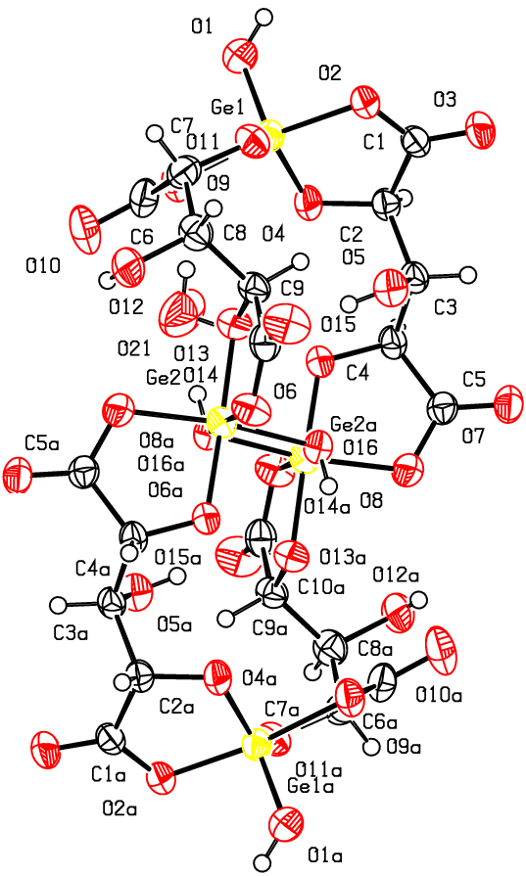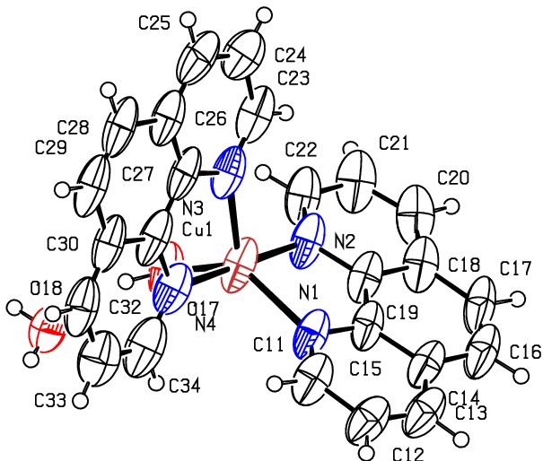03c

s155_s p -1 R 0.06 RES= 0 39 X

